James Richard Purcell
Service No. 5080
Rank: Private
Unit: 22nd Battalion
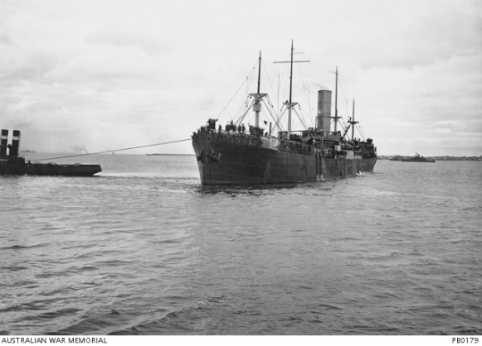
James Richard Purcell was born in Greensborough in 1896, the son of Edward Caledonian Purcell and Mary Julia Gerrock. At the time of his enlistment the family was living at Greensborough. He was 19 years old and working as a labourer when he enlisted on 11th February 1916.
After training he travelled on HMAT Ayrshire A33 on 3rd July 1916 and landed in Plymouth on 2nd September 1916. He completed his training with 6th Training Battalion in England.
He was sent to France on 13th November 1916 and taken on strength of the 22nd Battalion on 27th November 1916.
Soon after, James was admitted to hospital for over three weeks suffering with mumps. He rejoined his battalion on 5th February 1917.
James Richard Purcell was killed in action 3rd May 1917 at Bullecourt. He is buried at Queant Road Cemetery, Buissy France.
He was awarded the British War Medal, Victory Medal and Memorial Plaque.
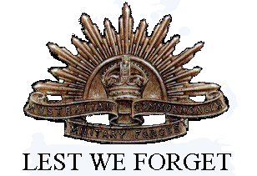
Following his father’s death in 1922, James’ mother received a small pension of 20 shillings per fortnight.
James Richard Purcell is commemorated in Greensborough on the Fallen Soldier’s Memorial, Greensborough Primary School Honour Board and the Greensborough and District Honour Board at the Greensborough RSL.

