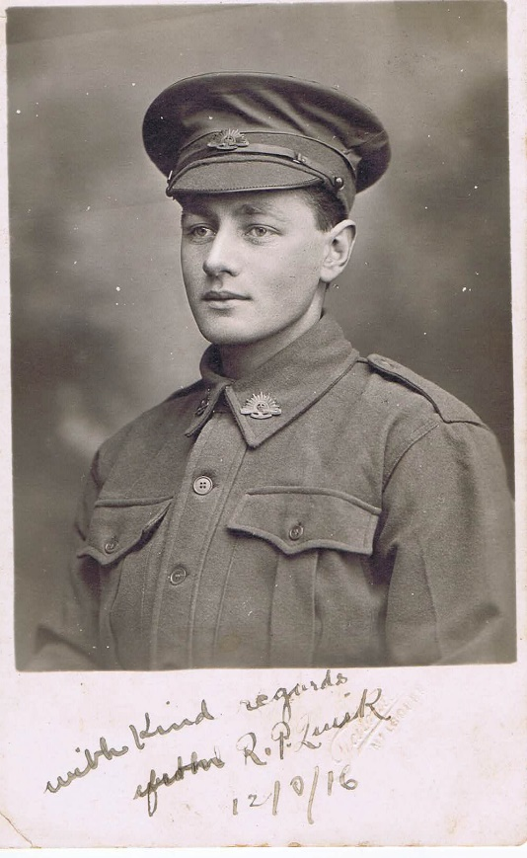
Roy Preston Quirk
Service No. 7348
Rank: Private
Unit: 21st Battalion
Roy Preston Quirk was born in Carlton in 1898, the son of Samuel Quirk and Rose Hanna Barratt. At the time of his enlistment the family was living at Greensborough. He was 18 years and 3 months old and working as a tailor when he enlisted 25th June 1916. When Roy’s parents gave permission for Roy to enlist, they specified that he was not to “leave Australia for service abroad until after his nineteenth birthday.” In January 1917, just three weeks before his 19th birthday, they gave permission for Roy to sail with his unit before his birthday.
After training in Geelong and Royal Park he travelled on HMAT Ballarat A70 and landed in England on 26th April 1917. He was taken on strength on 1st September 1917 and saw active service in France.
Roy was hospitalised with severe dysentery in August 1918 and invalided to England. While recuperating at Sutton Very, Roy is noted as absent without leave on Christmas Day.
Roy Preston Quirk returned to Australia in April 1919. While on board the ship ‘Kashmir’, he was hospitalised with mumps. Roy received a medical discharge on 30th May 1919.
He was awarded the British War Medal and Victory Medal.
Roy Quirk is commemorated in Greensborough on the Greensborough Primary School Honour Board and the Greensborough and District Honour Board at the Greensborough RSL.
Roy re-entered life in Greensborough in the inter-war years. Reports in the local papers refer to his singing at weddings, church and other social events. From Hurstbridge Advertiser 3 May 1935 [retrieved from Trove]: “At night a special Anzac service, conducted by the Rev. G. Arthur M.A., was held in the Greensborough Methodist Church. The text chosen was "Follow after the things which make for peace." An eloquent tribute, was paid to all those who had made the supreme sacrifice. Mr. Roy Quirk, who was en route for the war and one of the company rescued when a transport was torpedoed, read the names of the local fallen from the church Honor Roll - Ben Starling, Jas. Purcell, Jas. Poulter, Doug Whittingham, D. J. Medhurst. A minute's silence was observed in their memory, and for all their fallen comrades. The church was decorated with white flowers and red, white and blue ribbons.”
In 1938 the Quirk family relocated to Brighton and was farewelled by the Greensborough Methodist Church as reported in the Hurstbridge Advertiser 29 April 1938 [retrieved from Trove]: “Presentations: Mrs. Quirk, Miss Leila Quirk, and Mr. Roy Quirk of Greensborough who are leaving to live in Brighton, were entertained at a gathering in the Methodist Church Hall on Wednesday night. The function was arranged by the Ladies' Guild, and the Rev. C. J. Wright presided over a large gathering. The family had lived at Greensborough for 30 years, and during that period, the members had been active workers in the church. Mr. Quirk was superintendent of the Sunday school, and member of the choir, while Miss Quirk was the organist. Mrs. Quirk was presented with an auto-tray, Miss Quirk, with beautiful crystal ware, while Mr. Quirk received a wallet of notes from the trustees, an attache case from the Sunday school, and an Eversharp pencil from the choir.”
Roy married Elizabeth Dilwen in 1940. Electoral rolls for the 1940s list Roy as a postmaster (Hastings 1943) and RAAF in 1949-1954 (Hastings) – this most likely a Citizen Military Forces role.
Roy Quirk died in 1979 in Hampton Victoria.
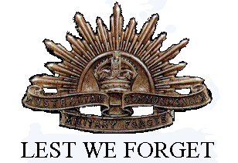
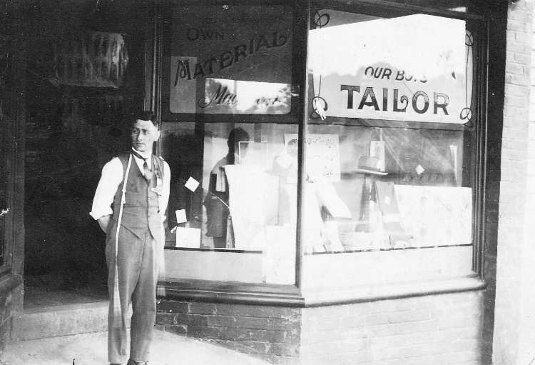

Roy Quirk outside his Tailor's shop in Greensborough

