Joshua Henry Robinson

Service No. 17359

Rank: Lance Corporal

Unit: 14th Field Ambulance

Joshua Robinson was born in Collingwood in 1896. He was the son of Joshua and Mary Agar. Joshua was working in the Insane Asylum, Mont Park at the time of his enlistment on 16th February 1916. He was aged 19 years 11 months. He gave his father who was also working at Mont Park as next of kin.

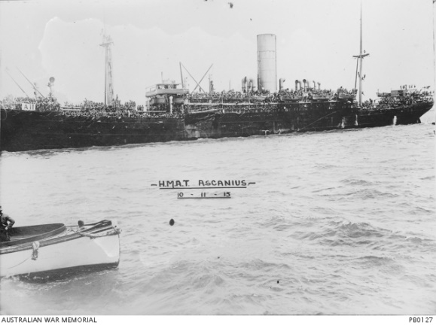On 6th March 1916 he was appointed to the staff of the Clearing Hospital at the Seymour (Vic) Military Camp. During this time, he rose to the rank of Sergeant, but was demoted to Acting Corporal later.

He served at this hospital until he embarked for England on HMAT Ascanius A11 on 11th May 1917 and landed in Devonport, England on 20th July 1917.

He served in France from 8th October 1917 with the 14th Field Ambulance. On 28th November 1917 he was promoted to Lance Corporal.

He returned to Australia serving as hospital staff on the Hospital Transport Konig Frederich August on 6th August 1919 and was discharged on 5th September 1919.

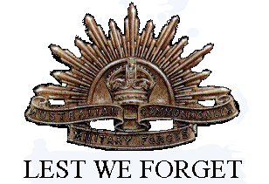Joshua Robinson received the British War Medal and the Victory Medal.

Post war he lived at Peel Street Kew in 1919. In 1924 he was living at Sandringham.

He passed away in 1957 at Eltham aged 61.