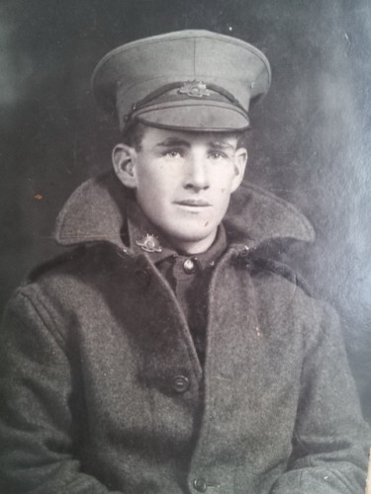
Francis Gordon Scott
Service No. 719
Rank: Private
Unit: 10th Machine Gun Company
Francis Gordon (Frank) Scott was born in Gawler South Australia in 1898, the son of Daniel Scott and Hannah Gibney. At the time of his enlistment the family was living at Diamond Creek. He was 18 years old and working as a railway porter when he enlisted on 21st February 1917.
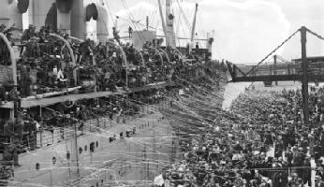
After training in Seymour at the Machine Gun Depot, and two stints at the isolation camp Ascot Vale following contact with mumps, Frank travelled on HMAT Aenaes A60 in October 1917 and landed in England where he joined the 6th Training Battalion in December 1917.
He was taken on strength of the 21st Battalion on 9th April 1918 and joined the battalion in the field on 18th April.
Francis Gordon Scott was killed in action on 10th June 1918 in France. He is buried at Mericourt L’Abbe Communal Cemetery Extension.
Frank Scott was awarded the British War Medal, Victory Medal and Memorial Plaque.
