Charles Benjamin Scrivener
Service No. 3155
Rank: Private
Unit: 5th Pioneers
Charles Benjamin Scrivener was born in Greensborough in 1891. He was the son of Thomas Scrivener of Bayswater WA. He was living in Guildford WA and working as a Survey Hand at the time of his enlistment at Blackboy Hill on 10th April 1916. He was aged 24 years 6 months. He gave his father as next of kin.
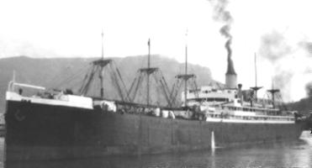
After initial training he embarked on HMAT Argyllshire A8 on 9th November 1916 and landed in England on 10th January 1917.
Charles served in France from 14th November 1917. He was gassed on 17th June 1918 and hospitalised until 21st August 1918 when he rejoined his unit.
He returned to Australia on the Konigin Luise on 3rd August 1919 and was discharged on 13th September 1919.
Charles Benjamin Scrivener received the British War Medal and the Victory Medal.
