Kenneth Gordon Sharpe
Service No. 2440
Rank: Private
Unit: 3rd Pioneers
Kenneth Gordon Sharpe was born in Lobethal South Australia in 1890, the son of Robert Sharpe and Agnes Lockhart who later lived in Greensborough. At the time of his enlistment Ken and his wife Eunice were living in North Fitzroy. He was 26 years old and working as a wool carder’s assistant when he enlisted on 4th July 1916.
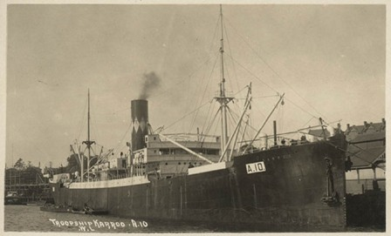
After spending time at the Isolation Camp Ascot Vale, Ken Sharpe embarked on HMAT Karoo A10 and disembarked in November 1916 in Plymouth England where he spent six weeks with the Pioneer Training Battalion. He was taken on strength in March 1917 and saw active service in France.
Twice in August 1917, Ken was admitted to hospital and again in January 1918. He was wounded in action (gassed) on 26th May 1918 and rejoined his unit a month later. Ken was gassed again on 29th September and sent to England for treatment. By the end of October he was diagnosed with influenza. He developed bronchio pneumonia and was moved to Fovant Military Hospital in Wiltshire where he died on 8th November 1918.
Kenneth Gordon Sharpe is buried at St George’s Parish Churchyard Military Section at Fovant. The official AIF burial report states: “The deceased was buried with full military honours the coffin draped with the Australian flag being borne to the graveside on a gun-carriage proceeded by a firing party and band from no.4 Australian Command Depot. Six of deceased’s late comrades supported the Pall. The funeral was attended by 2 Officers and 10 NCOs and Men of No.4 Command Depot. Wreaths from officers and comrades of No.4 Command Depot …and 3 comrades were placed on the grave. Headquarters A.I.F. Depots in United Kingdom were represented at the funeral.”
Ken’s brothers William Sharpe (Service no. 5417) and John Gillespie Sharpe (Service no. 12396) were also present at his funeral.
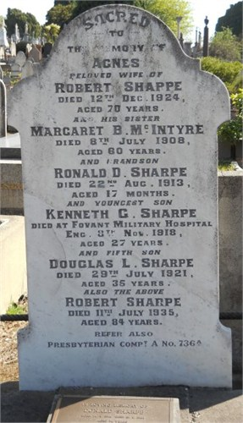
Kenneth Sharpe is commemorated on his parent’s headstone at Boroondara General Cemetery Kew, Victoria.
He was awarded the British War Medal, Victory Medal and Memorial Plaque.
Kenneth Gordon Sharpe is commemorated in Greensborough on the Fallen Soldier’s Memorial and the Greensborough and District Honour Board at the Greensborough RSL.

