William David Sharpe
Service No. 5417
Rank: Corporal
Unit: 24th Battalion
William David Sharpe was born in Stirlingshire, Scotland in 1882. He was the son of Robert Sharpe of Greensborough. William was living in Greensborough working as a belt maker when he enlisted on 13th March 1916, aged 33 years, 11 months. He gave his father Robert as next of kin.
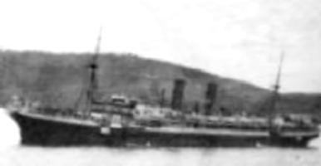
After initial training he embarked on HMAT Miltiades A28 on 1st August 1916 and landed in England on 23rd September 1916. On 21st December 1916 he commenced service in France.
During 1917 he had a number of stays in hospital with undisclosed sicknesses, a dislocated shoulder and a fractured ankle.
He was transferred to England with the dislocated shoulder on 28th December 1917 and completed his service in England.
During this time he attended the funeral of his brother Kenneth Gordon Sharpe in England. Kenneth died of pneumonia and bronchitis on 8th November 1918, just 3 days before the Armistice.
He returned to Australia on the Hospital Transport Aeneas arriving on 12th July 1919 and was discharged on 13th September 1919.
William Sharpe received the British War Medal and the Victory Medal.
He passed away at Maidstone in 1951 aged 67.
