Frederick Thomas Snodgrass

Serial No. 1097

Rank: Lance Corporal

Unit: 5th Infantry Battalion

Frederick Thomas Snodgrass was born in 1895 in Yea, Victoria, the son of Archibald Augustus Hare Snodgrass and Emily Louisa Ward Davey.

When he enlisted at Kerang on 5th October 1914 he gave his uncle’s name as his next of kin, with the notation (no parents). In fact his father was serving overseas in the 1 Australian Remount Unit in 1914 and then in the 4 Light Horse Regiment in 1917.

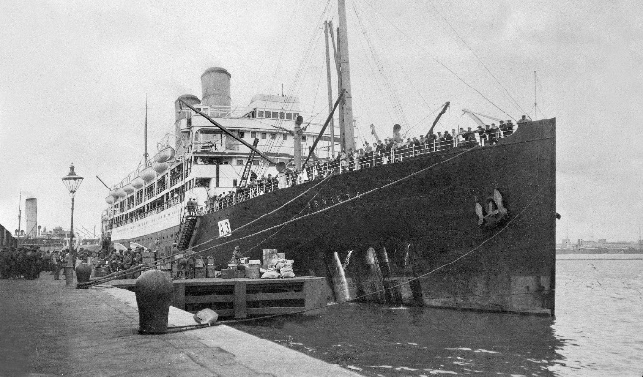

He embarked on HMAT Orvietto A3 and saw active service in France and Belgium.

He was admitted to hospitals in England and Cairo for diphtheria twice during his service and was wounded in action three times.

Fred was mentioned in dispatches in April, 1917. “This soldier was a member of the special section of the Intelligence Platoon, which was detailed to reconnoitre the enemy position, previous to a raid. He reconnoitred No Man’s Land in the daylight, and after the raid was most active in searching No Man’s Land for wounded comrades and evidence. He also, after his duties were finished, volunteered for and carried out the duties of stretcher bearer.”

Frederick Snodgrass was killed in action 20 September 1917 at Menin Gate, Belgium. He was buried 300 yards west of Glencorse Wood.

On his file are letters requesting information from the next of kin given on the enlistment form - his uncle, Ernest Davey, a cordial manufacturer in Kerang, as to where to send his victory medals. Ernest replied that Frederick had no brothers or sisters living; his mother was also dead, and he had no knowledge of his father, so the medals should be sent to him at Kerang. However the army ascertained that his father was still living and had returned to Australia from the Veterinary Hospital on 27th January 1920 and so the medals were to be sent to him. The receipt for his memorial plaque was signed by his father A. A. H. Snodgrass on 23rd September 1922.

Probably the reason that Frederick has been included on the Greensborough War Memorial is because another uncle, John Henry Davey, lived at Plenty Farm, Greensborough. Quite likely Frederick was one of the nephews that were employed on the dairy farm from time to time. John Davey’s son Robin had also been killed in the war and his name was being inscribed on the War Memorial so the family thought it was fitting that Frederick’s sacrifice should also be remembered.

He is commemorated at Menin Gate Memorial, Ypres, Belgium. Frederick is commemorated in Greensborough on the Fallen Soldier’s Memorial.

*Greensborough Historical Society World War I Project thanks Sylvia Tupper for her story on Fred Snodgrass*

