George Cornforth Snowdon
Service No. 3230
Rank: Private
Unit: 50th Battalion
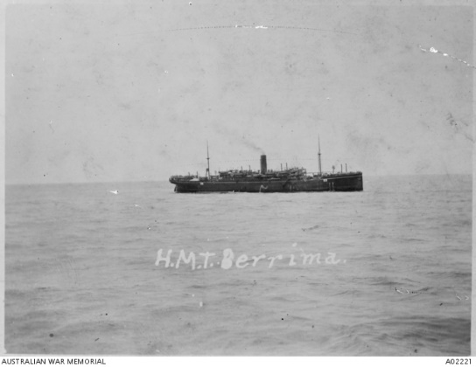
George Cornforth Snowdon was born in Sunderland, England, the son of George Snowdon and Helen Gardiner. At the time of his enlistment the he was living at Terowie, South Australia. He was 43 years and 2 months old and working as a labourer when he enlisted on 9th October 1916. George’s next of kin was his sister Christine Margaret Ann Cameron living at Hailes Street, Greensborough.
After training he embarked on HMAT Berrima A35 on 16th December 1916 and landed in England. He was taken on strength in the 22nd Battalion and saw active service in England
He was considered medically unfit (after a hernia operation August 1916 at Adelaide Hospital) and returned to Australia on the Nestor 21st September 1917. Date of discharge 3rd December 1917.
George Cornforth Snowdon received the British War Medal.
He died on 16th February, 1951 in South Australia.
