Charles Henry Southern
Service No. 1934A
Rank: Private
Unit: 3rd Pioneers and 1st Machine Gun Battalion
Charles Henry Southern was born in Brunswick in 1892, the son of John Henry (Jack) Southern and Ellen Matheson. At the time of his enlistment he and his wife Evelyn Agnes Culph (also his next of kin) were living at Greensborough. He was 23 years old and working as a Metropolitan Fireman when he enlisted on 16th December 1915.
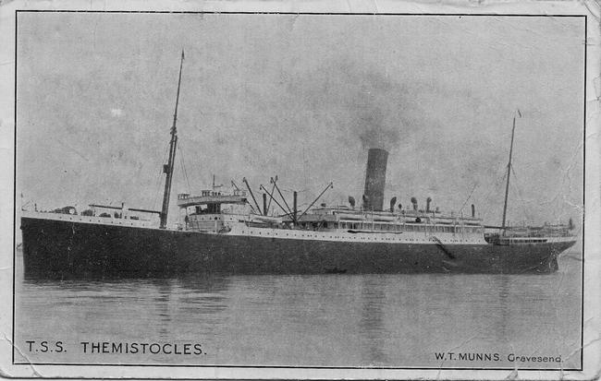
He embarked on HMAT Themistocles A32 and landed in England. He was taken on strength on 16th November 1916 and saw active service in France and Belgium.
On 18th February 1917, Charles was admitted to hospital in France, suffering with influenza. By April he was diagnosed with trench foot and transferred to England. Once recuperated, he was given a two week furlough to report to Hurdcott (an AIF Clearing Hospital) at the end of May. In August 1917 Charles was sent to the Overseas Training Battalion at Perham Downs in the Salisbury Plain.
He was returned to France and taken on strength in March 1918, transferred to the 1st Machine Gun Battalion on 9th April. In June Charles was again admitted to hospital in France, suffering influenza. He rejoined the 1st Machine Gun Battalion on 12th July 1918.
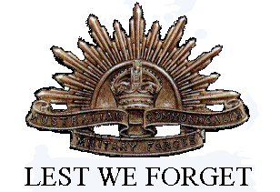
Charles Henry Southern received a shell wound (fractured skull) and died of his wounds 18th September 1918 in France. He is buried at Doingt Communal Cemetery Extension France.
He was awarded the British War Medal, Victory Medal, Memorial Plaque and Scroll.

