Reginald Thwaites Spencer
Service No. 1651
Rank: Lance Corporal.
Unit: 4th Light Horse Regiment, 1st Division Cyclist Corps & 8th Battalion.
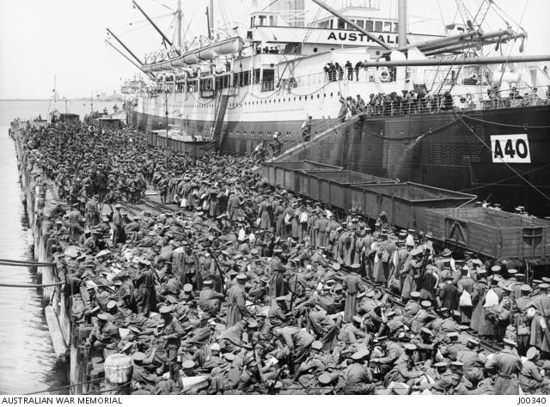
Reginald Thwaites Spencer was born in Mildura in 1898, the son of Robert Beauchamp Spencer and Alice Janet Thwaites. At the time of his enlistment the family was living at Bundoora. He was 18 years and 1 month old and working as a Tanner when he enlisted on 6th May, 1915. Reginald named his father Robert Beauchamp Spencer as next of kin.

After training he embarked on HMAT Ceramic A40 on 23rd November 1915 and landed in France. He was taken on strength in the 4th Light Horse Regiment and saw active service on the Western Front in France.
He returned to Australia on the Armagh on 18th May 1919.
Reginald Thwaites Spencer was awarded the 1914/15 Star, British War Medal, and Victory Medal.
Reginald married Muriel Vera McKay in 1919 in Brunswick, Muriel died in 1936. He married Flora McKinnon Leslie Aveling in 1936 in Bathurst.
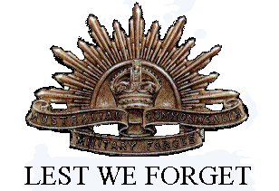
Other members of the Spencer family to enlist were his father Robert Beauchamp Spencer (service no. 3642), and his two brothers Arthur James Spencer (service no. 6891) and Robert John Spencer (service no. 4219).

