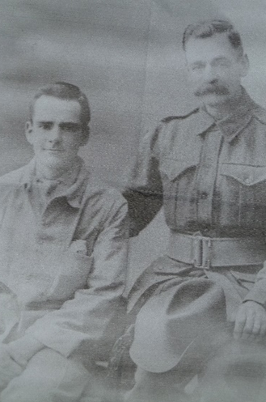
Robert Beauchamp Spencer
Robert Beauchamp Spencer with one of his sons
Service No. 3642
Rank: Private
Unit: 3rd Pioneers
Robert Beauchamp Spencer was born in Barry’s Reef in 1874. He was the son of John Spencer and Eliza Dolling. Robert was living in Bundoora and working as a driver at the time of his enlistment on 8th October 1917 and was aged 43 years 5 months. He gave his wife Alice as next of kin.
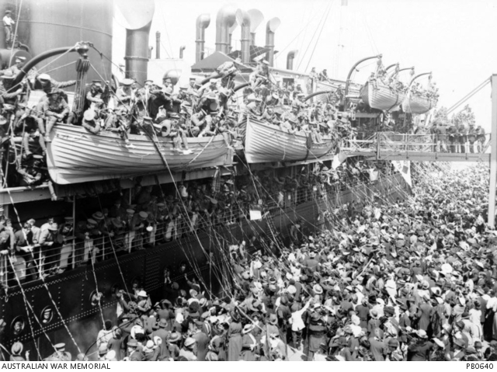
After initial training he embarked on HMAT Nestor A71 on 21st November 1917 and arrived at the Australian Camp at the Suez Canal on 15th December 1917. He was then transferred to the Training Battalion in England where he arrived on 2nd February 1918 and stayed for the remainder of the war.

Robert returned to Australia on the Hospital Transport Takara suffering from chronic rheumatism arriving on 11th February 1919. He was discharged on 26th February 1919.
Robert Beauchamp Spencer received the British War Medal.
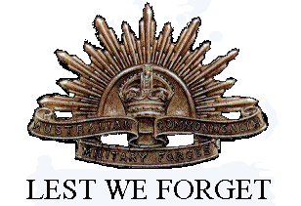
He passed away in 1935 at Dromana Bush Nursing Hospital aged 61.
Three of Robert’s sons also served: Arthur James Spencer (service no. 6891), Reginald Thwaites Spencer (service no. 1651) and Robert John Spencer (service no. 4219).

