Robert John Spencer
Service No. 4219
Rank: Private
Unit: 22nd Battalion & 60th Battalion
Robert was born in Mildura in 1894, the son of Robert Beauchamp Spencer and Alice Janet Thwaites. At the time of his enlistment the family was living at Park Street, Parkville. He was 21 years and 4 months old and working as a Cartage Contractor when he enlisted on 10th January 1916.
His next of kin was originally his father, living in Bundoora. Following his marriage, his wife Mrs Rose Spencer of Parkville became his next of kin.
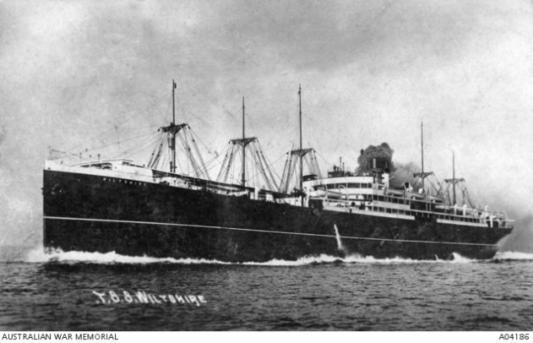
After training he embarked on HMAT Wiltshire A18 on 7th March 1916 and was taken on strength in the 60th Battalion in Egypt. After a week he was admitted to the Field Ambulance with ‘defective eyesight’. Robert’s overseas service was short-lived due to his poor eyesight. By June, he was suffering from ‘Melancholia’ and was again hospitalised.
He returned to Australia on the HMAT Karoola August 1916 and given a medical discharge.
Robert Spencer received the British War Medal
Other members of the Spencer family to enlist were his father Robert Beauchamp Spencer (service no. 3642), and his two brothers Reginald Thwaites Spencer (service no. 1651) and Arthur James Spencer (service no. 6891).
