Harry Frederick Miller
Service No. 10646
Rank: Sapper
Unit: 3rd Division Signals
Harry was born in Measden Middlesex England about 1880. His wife Mrs Maud Miller was given as his next of kin, Maud’s address was Post Office Greensborough.
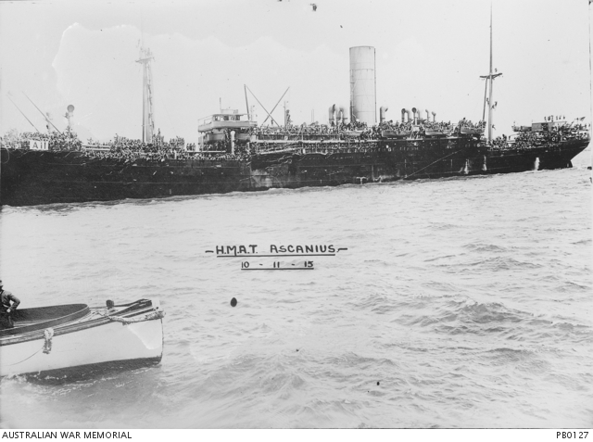
He was aged 25 years 7 months, employed as a labourer when he enlisted on 13th January 1916.
After training he embarked on HMAT Ascanius A11 on 25th May 1916 and landed in England on 18th July 1916.
Harry served in France and was wounded in action on 11th August 1917 and later had some time in hospitals with illnesses.
He returned to Australia on the Shropshire on 16th May 1919. He was discharged on 15th July 1919.
He received the British War Medal and the Victory Medal.

