Percival Albert Amiet and Family Information
by David Amiet
Percival Albert Amiet: Service number: 4005 Rank: Private Roll title: 22 Infantry Battalion - 9 to 12 Reinforcements (February-April 1916) Conflict: First World War, 1914-1918 Date of embarkation: 8 February 1916 Place of embarkation: Melbourne Ship embarked on: HMAT Warilda Ship number: A69
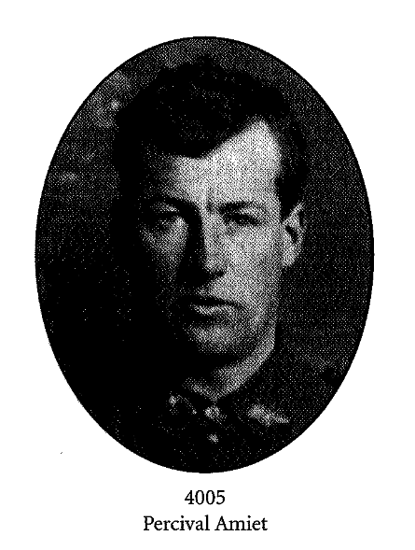
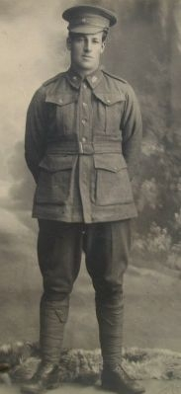

Source of Oval Portrait Above: http://armybooks.net/wp-content/uploads/2011/05/With-the-Twenty-Second-Book-Preview.pdf

Some Information about Percival Albert Amiet

Percival enlisted in WW1 at the age of 33 and was shot in the knee while en route to the battle at Mont St. Pelier. He and his family believe that this probably saved his life as he was repatriated to England, where he lost his kneecap. The wound recovered pretty well and according to his family, didn't affect him that much as he died about 3 months short of his 100th Birthday.

Percival ran the family Dairy Farm at Korumburra for many years and the story is told of how the family endured the 1939 Black Friday Bushfires by lying down in the furrows of the potato patch!

Eventually the Dairy Farm went bust whilst under the managership of Les Amiet (Percival's son to his second wife) and Les returned to live in Melbourne. It is interesting to note that 2 of Les's daughters played Basketball for Australia.....apparently they were very TALL!!

Percival lost his first wife as she died young, he later remarried and his second wife again died young.

Information supplied by Richard Gary Amiet in a letter to David Amiet in October 2009.

Notes Re Above Information:

Percival’s first wife was Agnes Kevis (or Kierce) Berry and she died on the 23rd July 1911. This is why one reads on Percival’s war records that his sister Rose Lillian Mitchell (nee Amiet) is listed as his next of kin and that part of his service pay was to be allotted to his son (from his marriage to Agnes): Claude Reginald Amiet. However another of Percival’s sisters (Ethel Beatrice Kell nee Amiet) raised Claude from an early age at the Kell’s dairy farm at Greensborough, Melbourne. Percival remarried in 1930 to Lillian Louisa Caroline Hawke bn 22 Aug 1900 and she passed away on the 29th June 1958 aged 57. Percival and Lillian had one child: Leslie Alexander Amiet: bn 23rd September 1931.

Percival passed away on the 12th December 1980 aged 99 years.

Below: Rose Lillian Mitchell nee Amiet

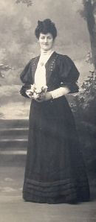
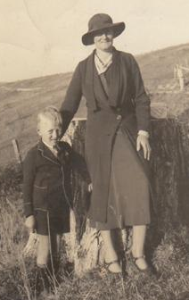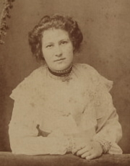

Above: Ethel Beatrice Kell Above: Lillian Hawke nee Amiet and Les Amiet pictured in 1936.
nee Amiet

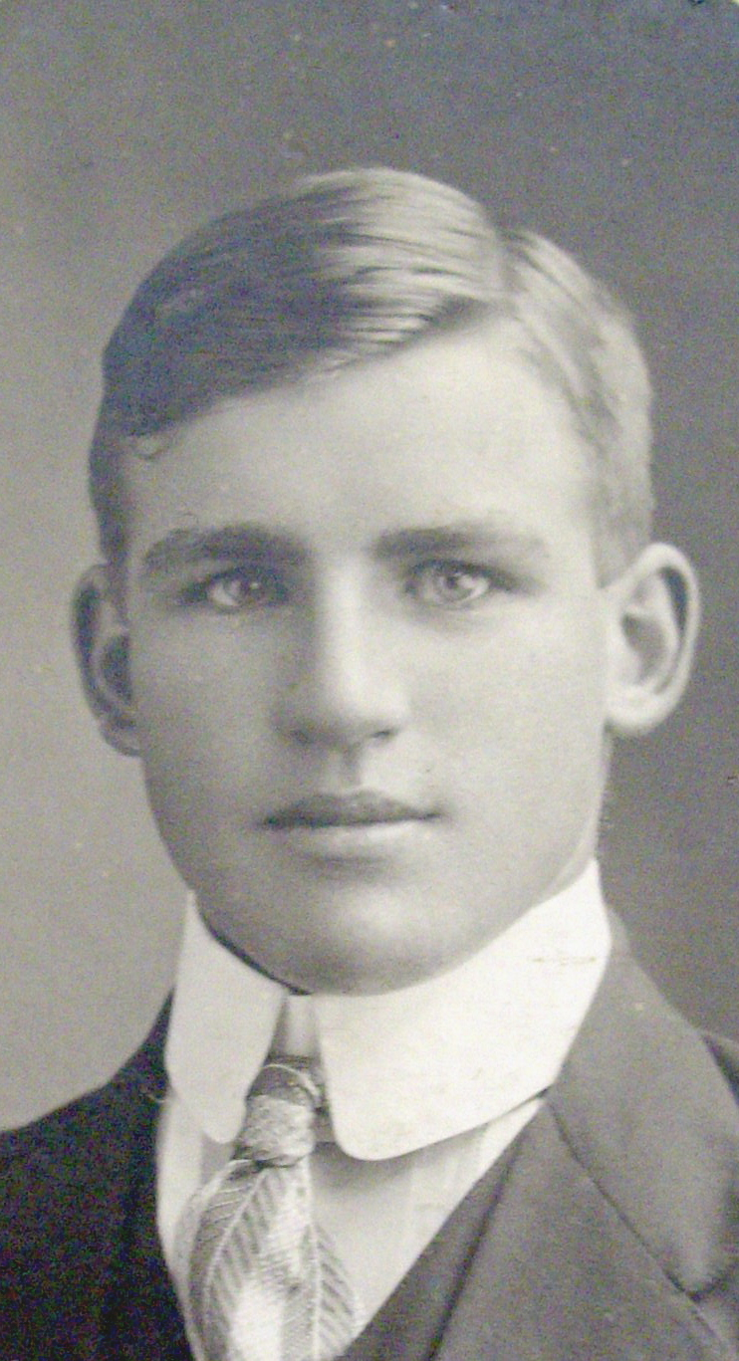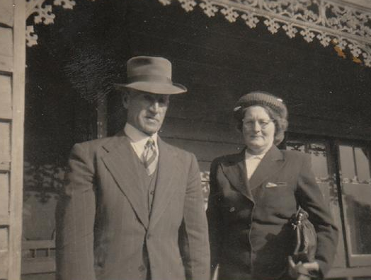

Above: Les Amiet Above: Perc and Lillian Amiet

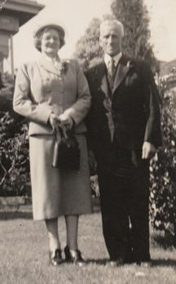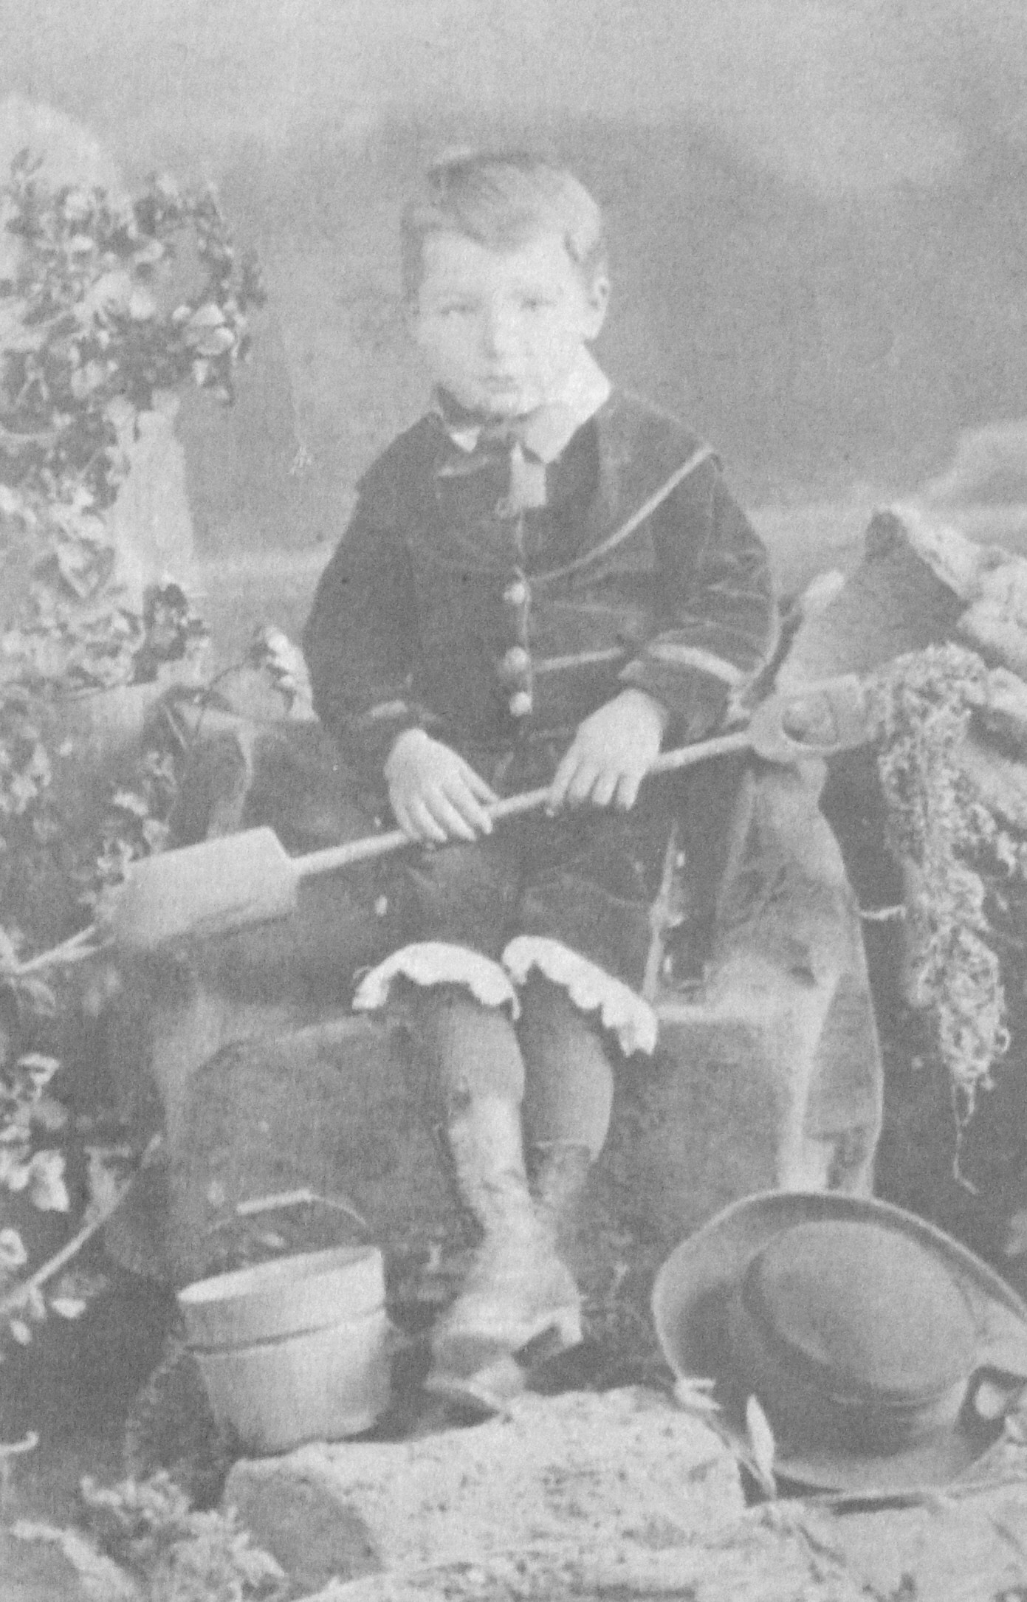

Above: Perc and Lillian Amiet in 1950. Above: Claude Reginald Amiet

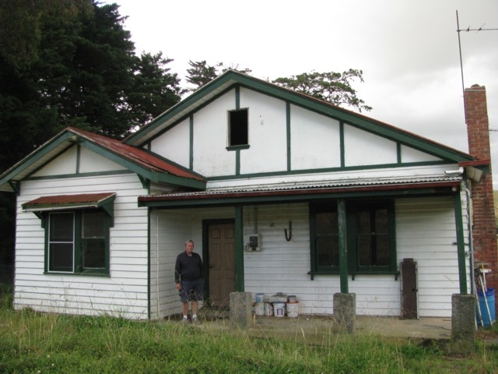

Above: Perc’s Dairy Farm at Korumburra Above: Perc’s Grandson Richard Gary Amiet standing outside Perc’s old House at Korumburra

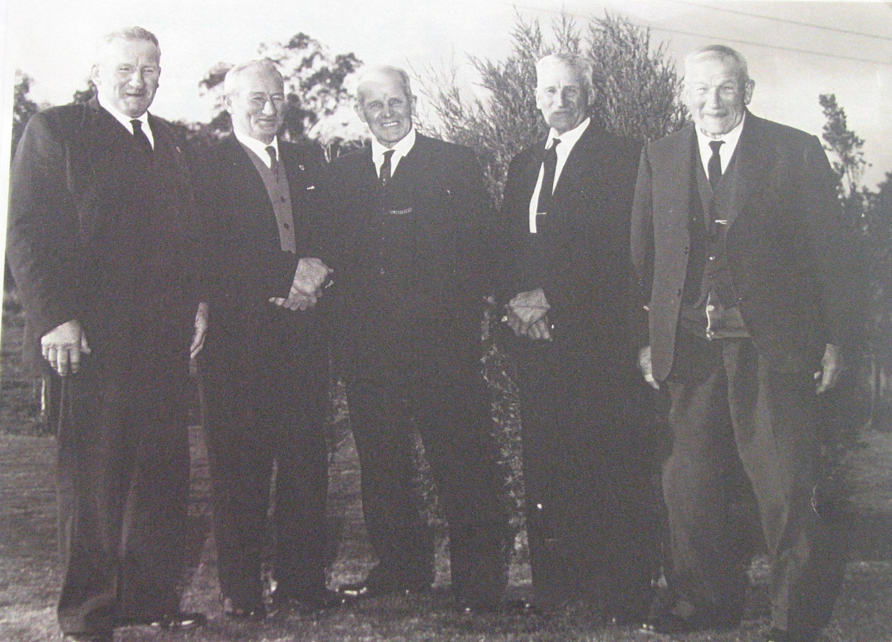

Above L-R: Les, Len, Reg, Perc and Fred Amiet

