Pivotal artefact from area’s history stolen from Diamond Valley Historical Society
Tiffany Korssen, Diamond Valley Leader
January 13, 2017 1:05pm
AN ANTIQUE horse-drawn plough from the 1800s has been snatched from the entrance of a Diamond Valley historical centre.
The thieves cut through several strong iron straps that secured the bulky artefact to the ground and hauled it over a large fence.
It had been adorning the entry of the Greensborough Historical Society — which is affiliated with the Royal Historical Society of Victoria — for about 18 months, after being donated by long-term local Gary Partington.
Mr Partington belongs to one of the oldest families in Greensborough, who lived on Partingtons Flat in the mid-1800s.
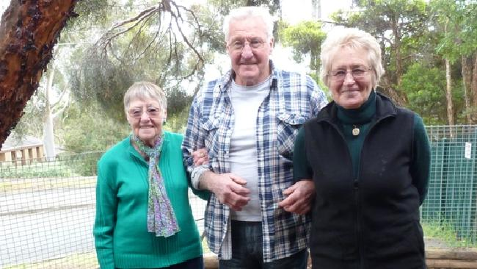Gary, Faye and their sister Elinor Partington at the Greensborough Historical Society.
“That plough was used back then by my family to work the land,” Mr Partington said.
“It’s a part of the area’s history from a different time, when houses had dirt floors and there was no electricity ... it’s very special not just to my family, but to all of Greensborough, that’s why I donated it.
“I’m devastated.”
Mr Partington, 73, and his sister Faye Fort, 79, said they were both bewildered about why someone would want to steal the hefty piece of machinery.
An antique kettle and shoe maker were also stolen.
“Other than to use them as garden ornaments, I’m not sure what you would want them for,” Mr Partington said.
“It would have taken at least two or three strong blokes to move the plough ... the whole thing is so strange.”
Greensborough Historical Society president Noel Withers said the theft most likely occurred between 1pm and 5pm on December 21.
“We’re all heartbroken, as the plough was a cherished, irreplaceable piece of our history and we are hoping it can be returned,” Mr Withers said.
“But we fear it has already been sold ... some people are very keen on items like these.”
Antique ploughs similar to the one stolen are advertised on eBay as “collectables” and range in price from $250-$1500.
Sergeant Stuart Cockerell urged anyone who may have noticed suspicious activity near the historical society on the corner of Glenauburn and Para roads in Lower Plenty to contact the Greensborough police station.
“Not only is it an extremely unusual thing to steal, it is very disappointing that someone would steal a piece of such historical significance for the area,” Sgt Cockerell said.
“If anyone has seen anything similar in someone’s backyard, please contact police.
“It’s likely someone knows where it is.”
Contact Greensborough police station on 8432 0200.
Details: greensboroughhistorical.org.au/

