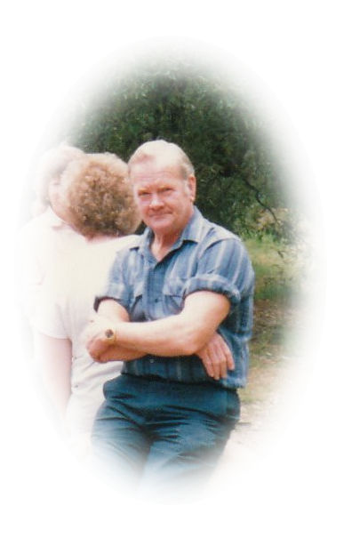
Allan Bishop remembers
the early years...........

I have had the privilege over the last twelve months, of talking with my Uncle Allan about his family life in days gone by. There were both great and difficult times – but memories were created, no matter what.

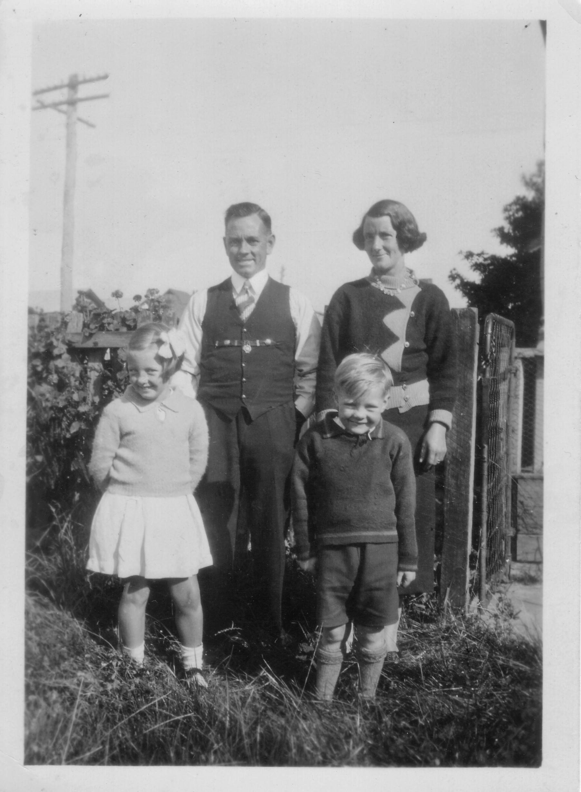
My name is Allan Frank Bishop born in February, 1931. The early years of my life were spent mainly around Thornbury and Northcote where we had many relatives; but I also spent around forty years living in the local Greensborough / Plenty area. My parents - Ernest Harold Bishop and Ada Myrtle Bishop (nee Hart), together with my sisters – Norma (born 1929) and Glenice (born 1946) and I, had some wonderful and yet also some difficult times during those early years.

Mum just loved moving from one house to another. From the time Mum and Dad were married, they moved house at least seventeen times that I am aware of. A fortune teller once told Dad that what he needed for Mum was a caravan!! Even into her 90’s, Mum’s one passion was looking through the real estate section of the newspaper, she just loved it.
Ern, Myrtle, Norma and Allan Bishop, April 1937

I can remember one instance at school in Thornbury when the boy that I sat next to contracted Polio. I was not allowed to attend school, nor mix with people for three weeks. During those weeks at home, Dad would sometimes put me on the push bike and take me for a ride around the local streets, just to get me out of the house for a while.

In August 1939, we went to live in Greenhills – at 61 Greenhill Road - for around twelve months when I was eight years old. My sister Norma and I attended Briar Hill State School whilst living there.
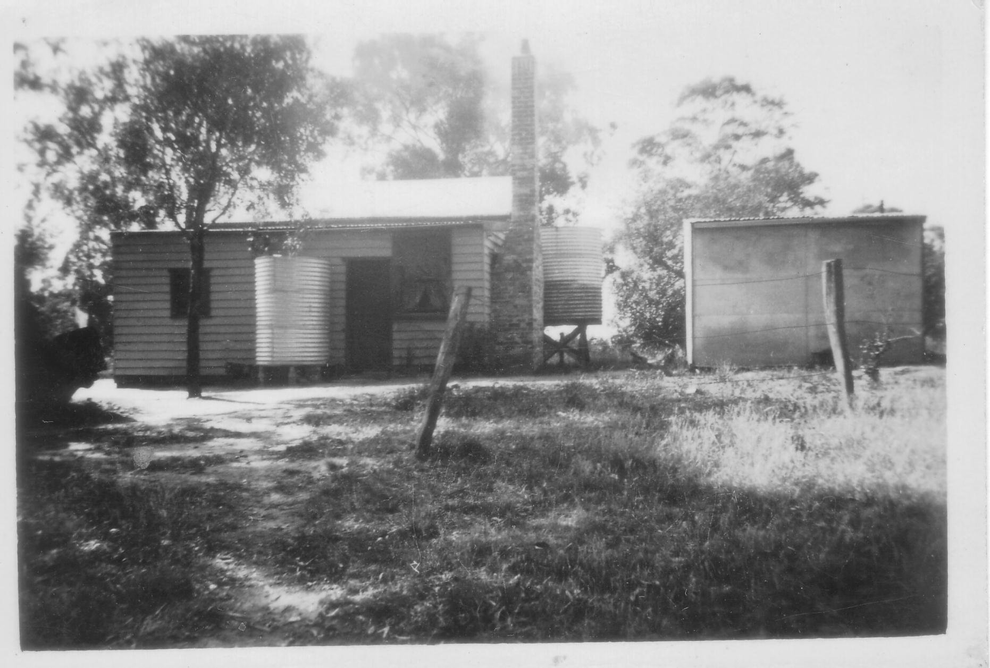
61 Greenhill Road

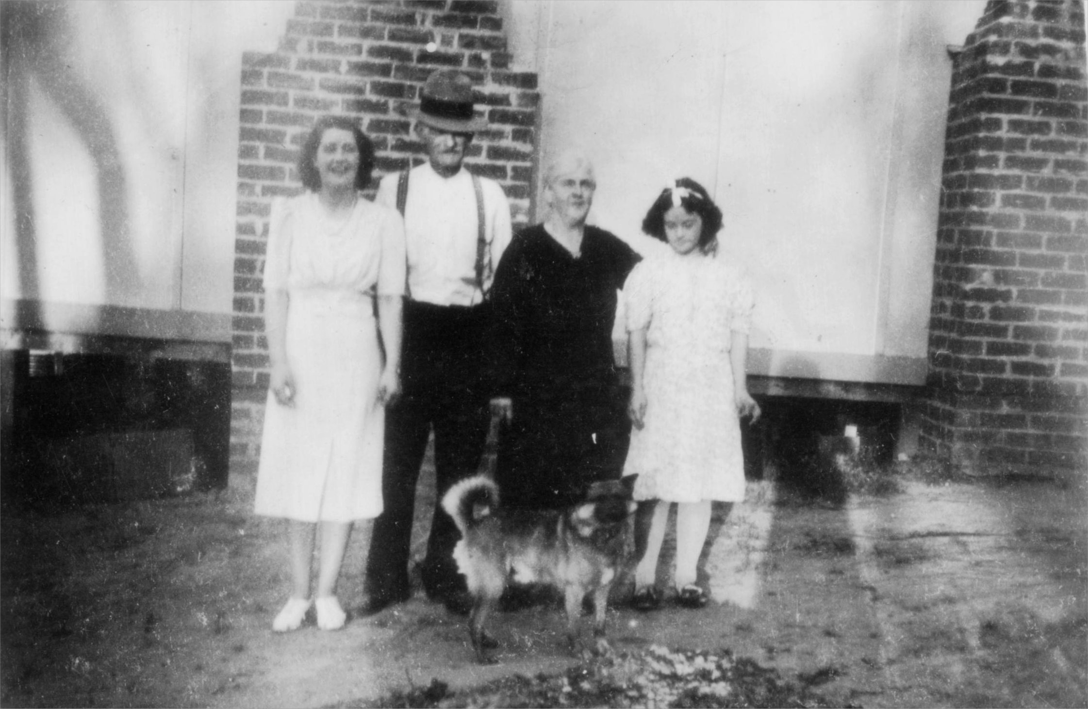
We had lots of good times growing up in Greenhills and there were many of our relatives living around the same area too. My Grandma - Ada Hart, with her daughters, Evelyn and Daphne – lived at 30 Carnon Street, Greenhills from about 1940 to 1942. Uncle Dick also lived at that address, but when he came back from the war, he could not stand living inside a house, so he lived in a tent next to the house.
Evelyn, Uncle Dick, Ada Hart and Daphne

We also had cousins Thelma and Dorothy with Auntie Jessie and Uncle Wilf living at 72 Greenhill Road. I still keep in touch with Thelma to this day, which is really special.
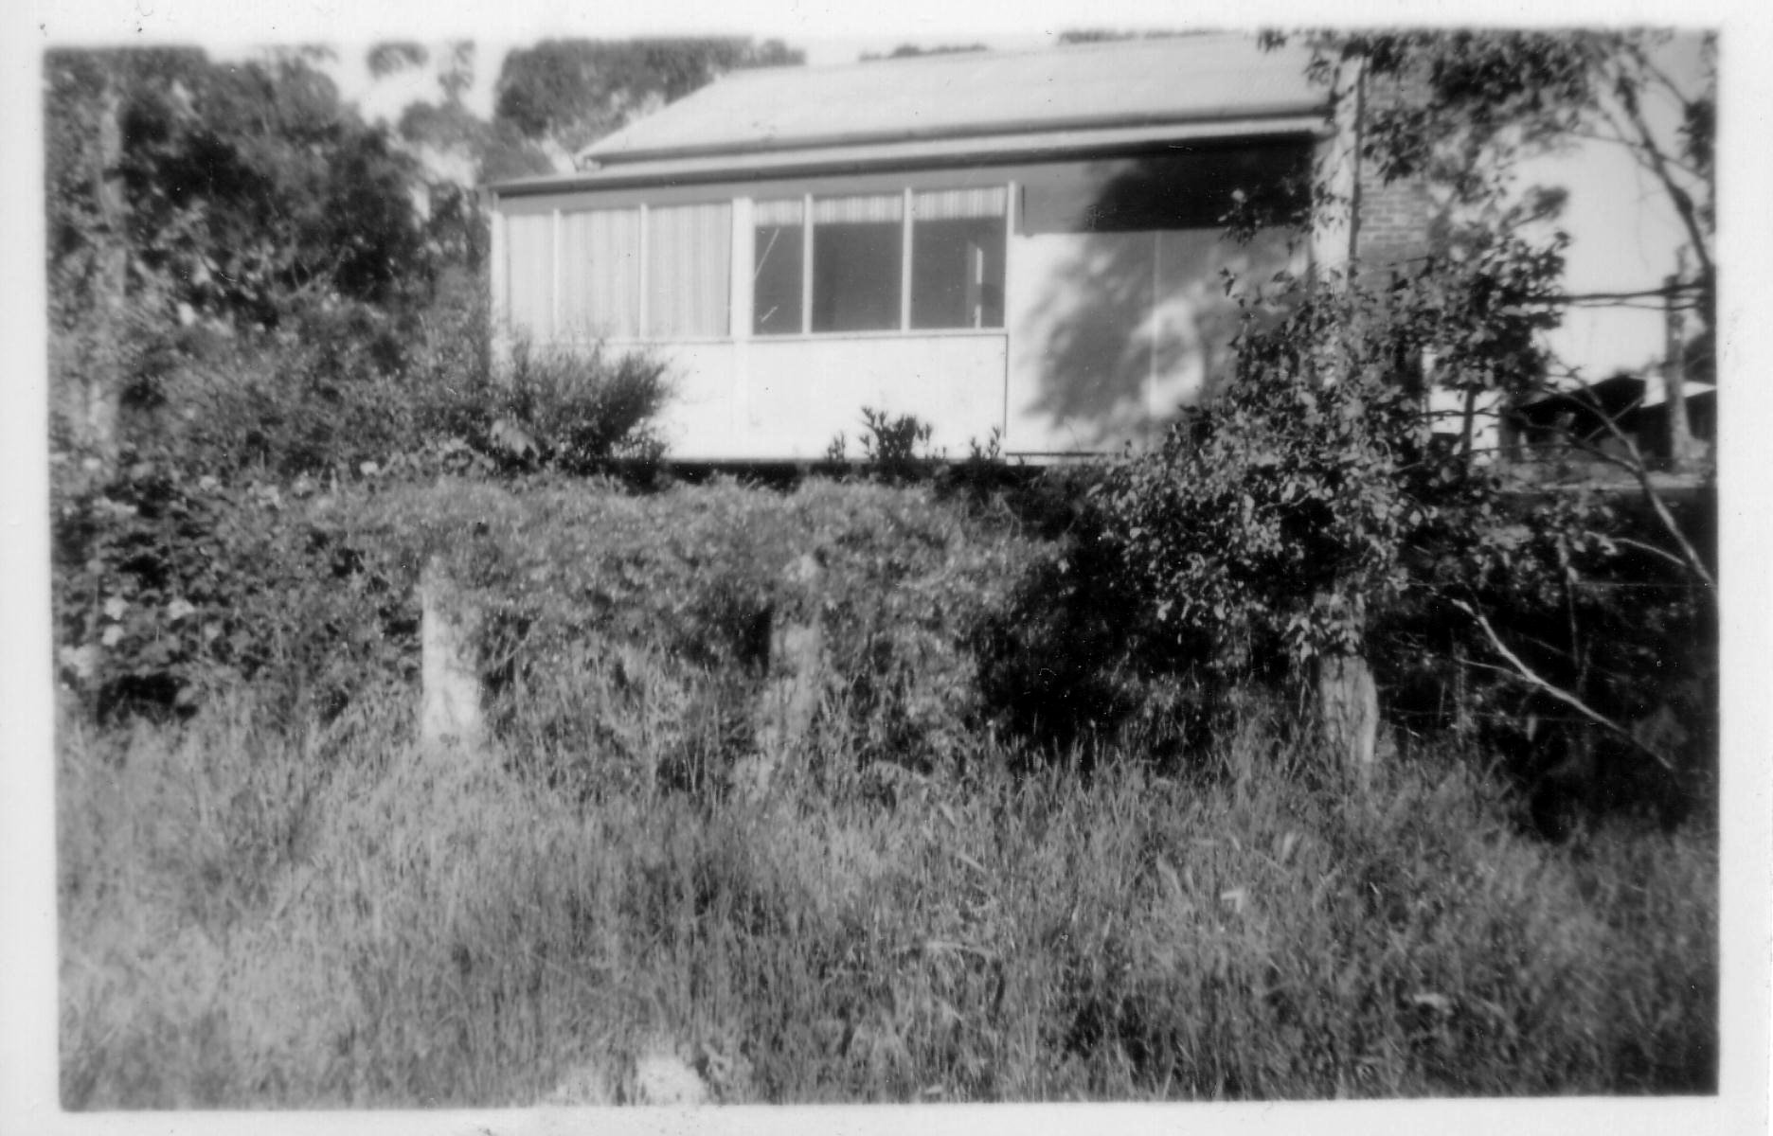
Around 1941, we moved back to Thornbury, Northcote and Chelsea before once again moving to Greenhills – 30 Carnon Street – around 1942.
30 Carnon Street
Our house in Carnon Street

At that time, there was no electricity in the area, so we had a kerosene refrigerator and lamps, only tank water, the toilet was a pan service, and we had a crystal set for the wireless / radio. There were very few houses around Greenhills at that time, and Mum would ring a cow bell to call us home for tea! We had to go to the Post Office in Greensborough to collect any mail. We had no telephone to begin with, but eventually we had that connected. There was a telephone exchange in the main street of Greensborough. When you went to make a call, you would pick up the hand piece of the telephone, wind the handle and ask the operator for the number that you wanted, and they would connect you to that telephone number. Milk was delivered to the house by us having a billy can ready to be filled from a large container, and the bread was delivered to the house by a man with a cart. I actually worked with the fellow on the bread cart for a while when I was about twelve years old. I would walk to Greensborough to begin the shift and we would travel around Greensborough and Greenhills for about three to four hours. I would run from the cart to the house, collect the money and leave the order of bread in its place.

It was fairly normal in those days that when you were old enough to leave school, you did so in order to get a job to help support the family. Things were pretty tough back then. We certainly had to learn the value of money and that you had to work hard to earn it. You appreciated everything that you had, did not waste anything, respected what belonged to others, and understood that sometimes you might have to go without, just to get by. One Christmas, Mum and Dad could only afford to buy one present - so my sister Norma got a book one year, and I got a book the next year. We were quite happy with that because we knew how difficult times were for the family at that point.
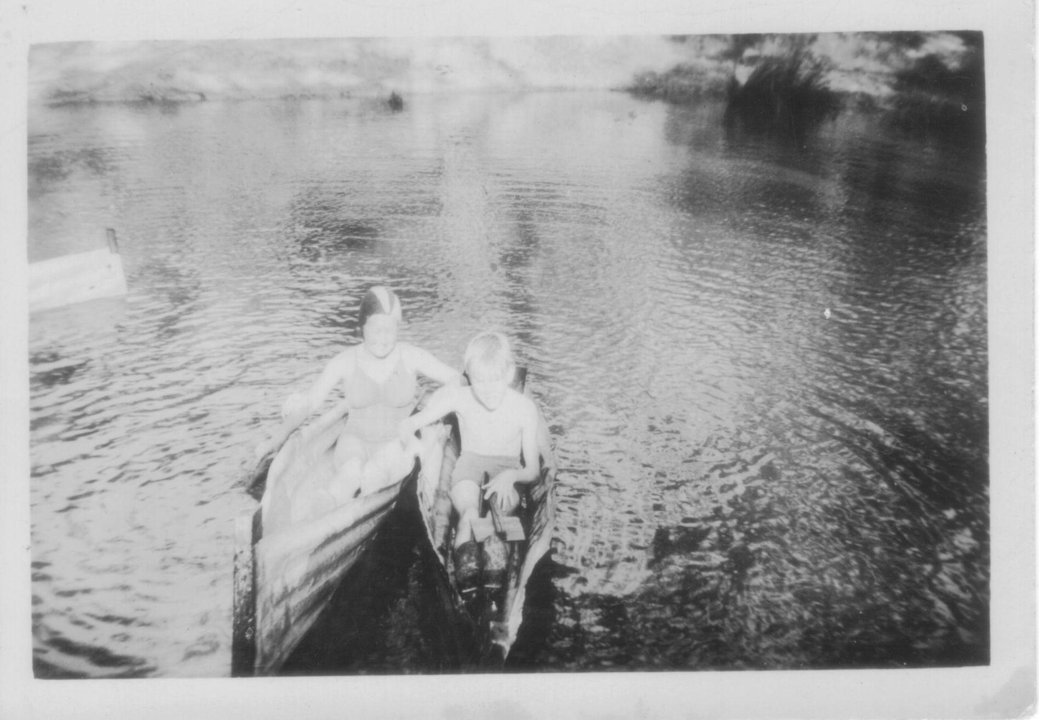
There were various activities that provided our entertainment in those days. There was a large dam in the area that many of us used to float around on in homemade boats which were made of corrugated iron. I sliced a rubber garden hose to put around the top edge of my boat so that it covered the sharp edges. One day, a friend and I spent an entire day carrying our tin boats down to where the swinging bridge was in Greensborough, launched the boats from there, and floated all the way to Railway Road Briar Hill. We then had to carry the boats all the way back to Greenhills! The outing filled the entire day.
Norma and Allan in tin boats

There was also a youth group that was held in the little bungalow near the front right hand side of Drakeford’s former Guest House at number 57 Greenhills Road.

There was a horse riding school in Greensborough in the early days, which was operated by a fellow called Benny Were. I would sometimes help him with washing the horses and Benny would pay me a small amount for doing that. On weekdays the horses would be hired out from near Henry Street, but on weekends they would be taken down to near the river – behind where Lovitts factory is today.

There were Scouts, Cubs, cricket and football for the boys, whilst my sister Norma attended GFS (Girls Friendly Society) and learned to play the piano. I was lucky enough to have a horse when living at Greenhills and one day I took myself and one of the other boys – Norman Wightman – with me by horse and jinker to Northcote.
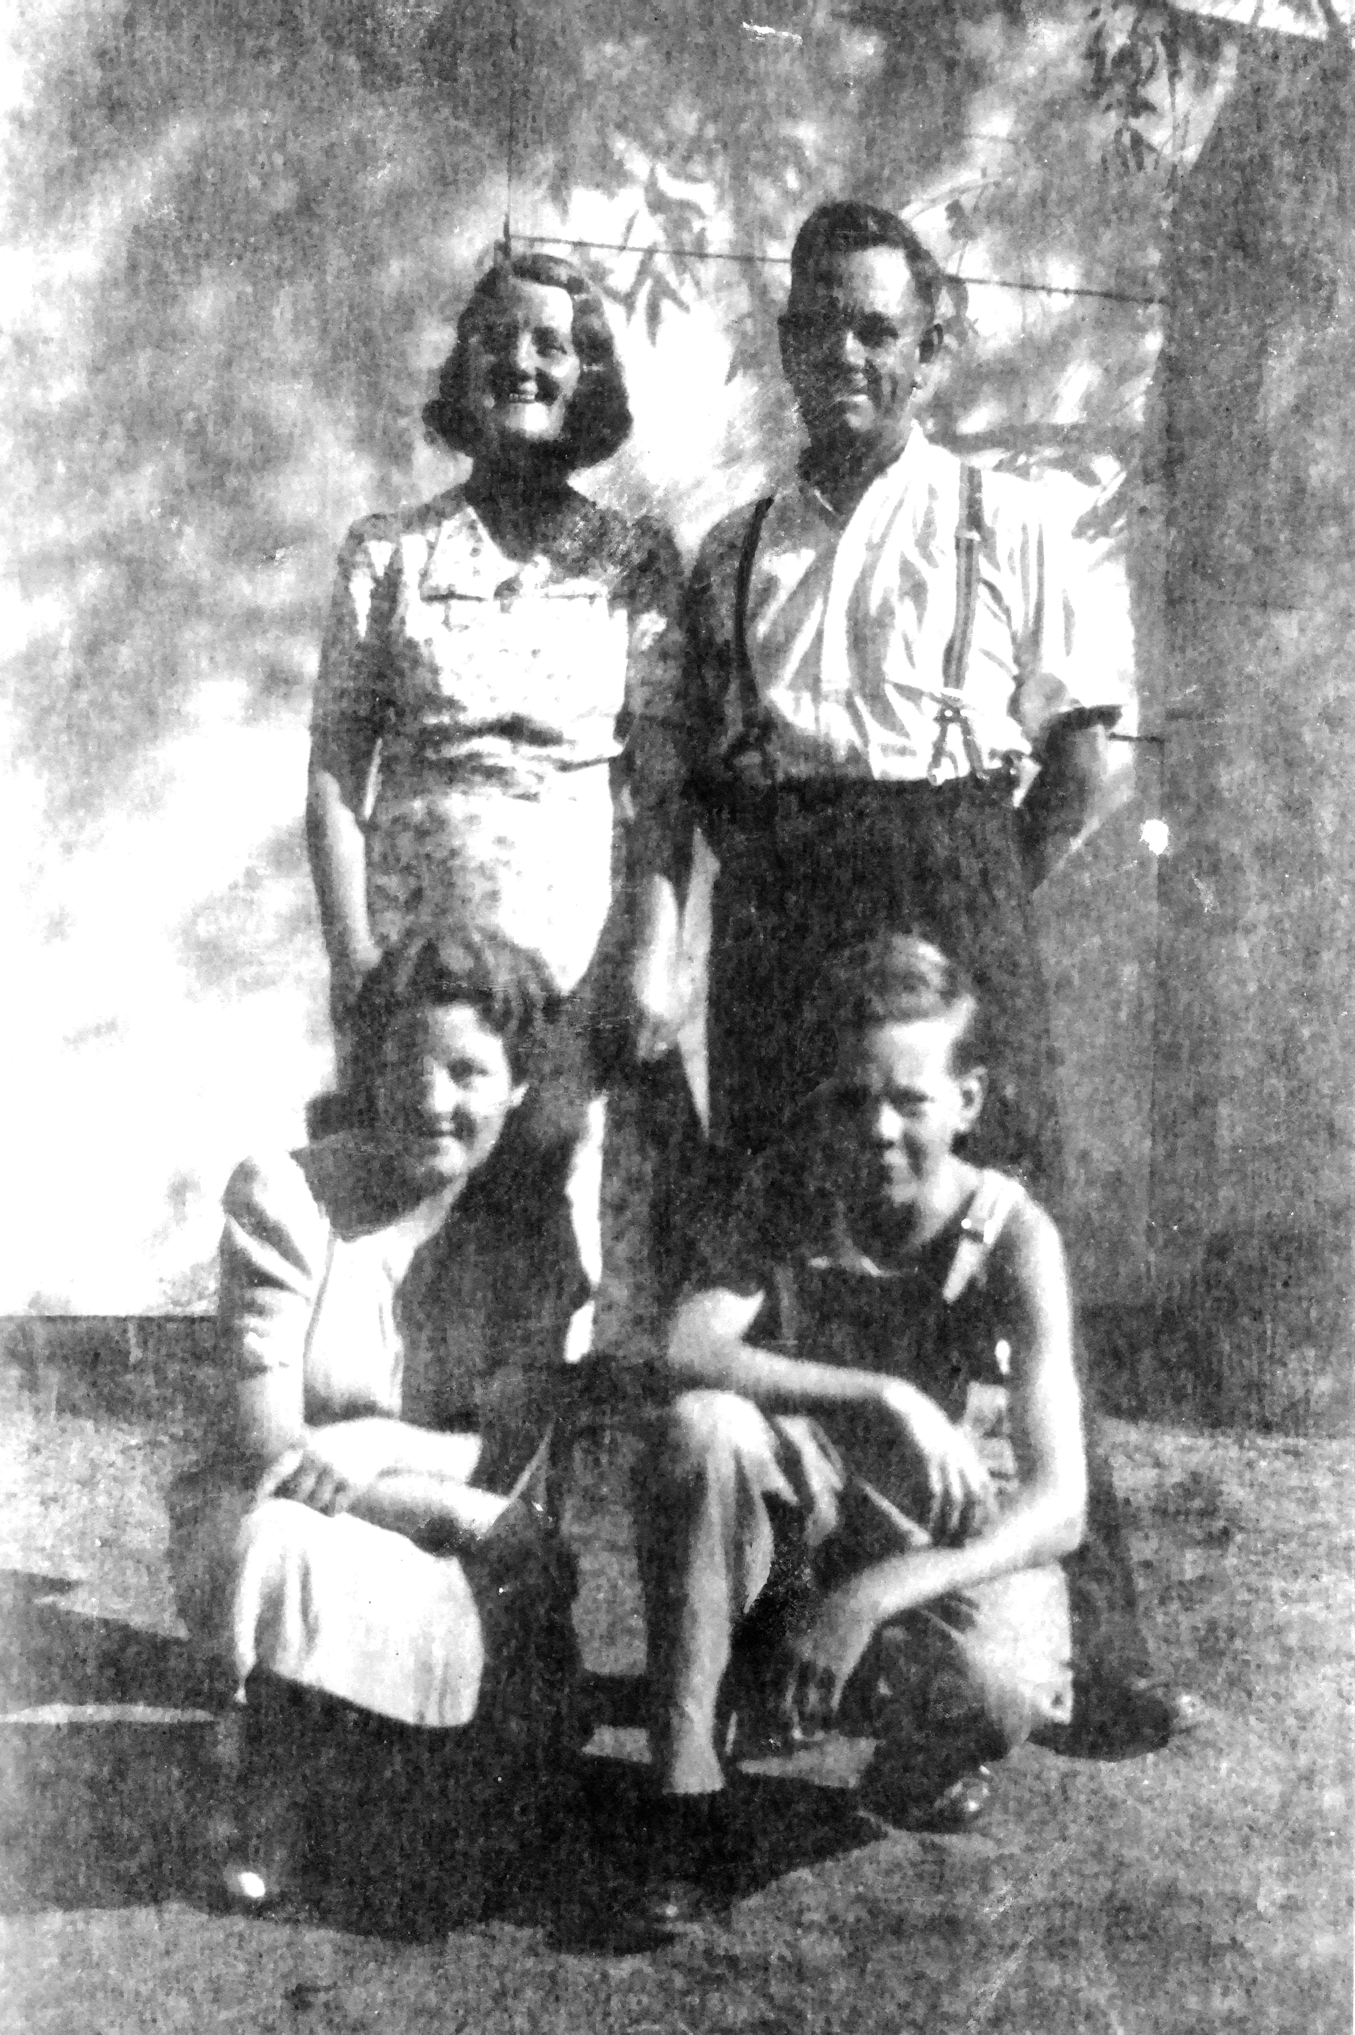
Myrtle, Ern, Norma and Allan – 1940’s

We would go ferreting for rabbits in the paddocks; walk to St Helena Church for Sunday School and go to the local dances.

A group of us would go to the pictures at Greensborough on a Saturday night. Going to the pictures was something that we had always done, whether it was the entire family, or just us as teenagers. When we lived in Thornbury, Dad, Mum, Norma and I, together with Aunties and Uncles, would go to the Gowerville Theatre on a Friday or Saturday night. Uncle Ron (Dad’s youngest brother) was the projectionist there. One night, Uncle Wal was there with children Alma and Valda, and when they went to leave – their yellow and black Hillman Minx had been stolen from outside the theatre!
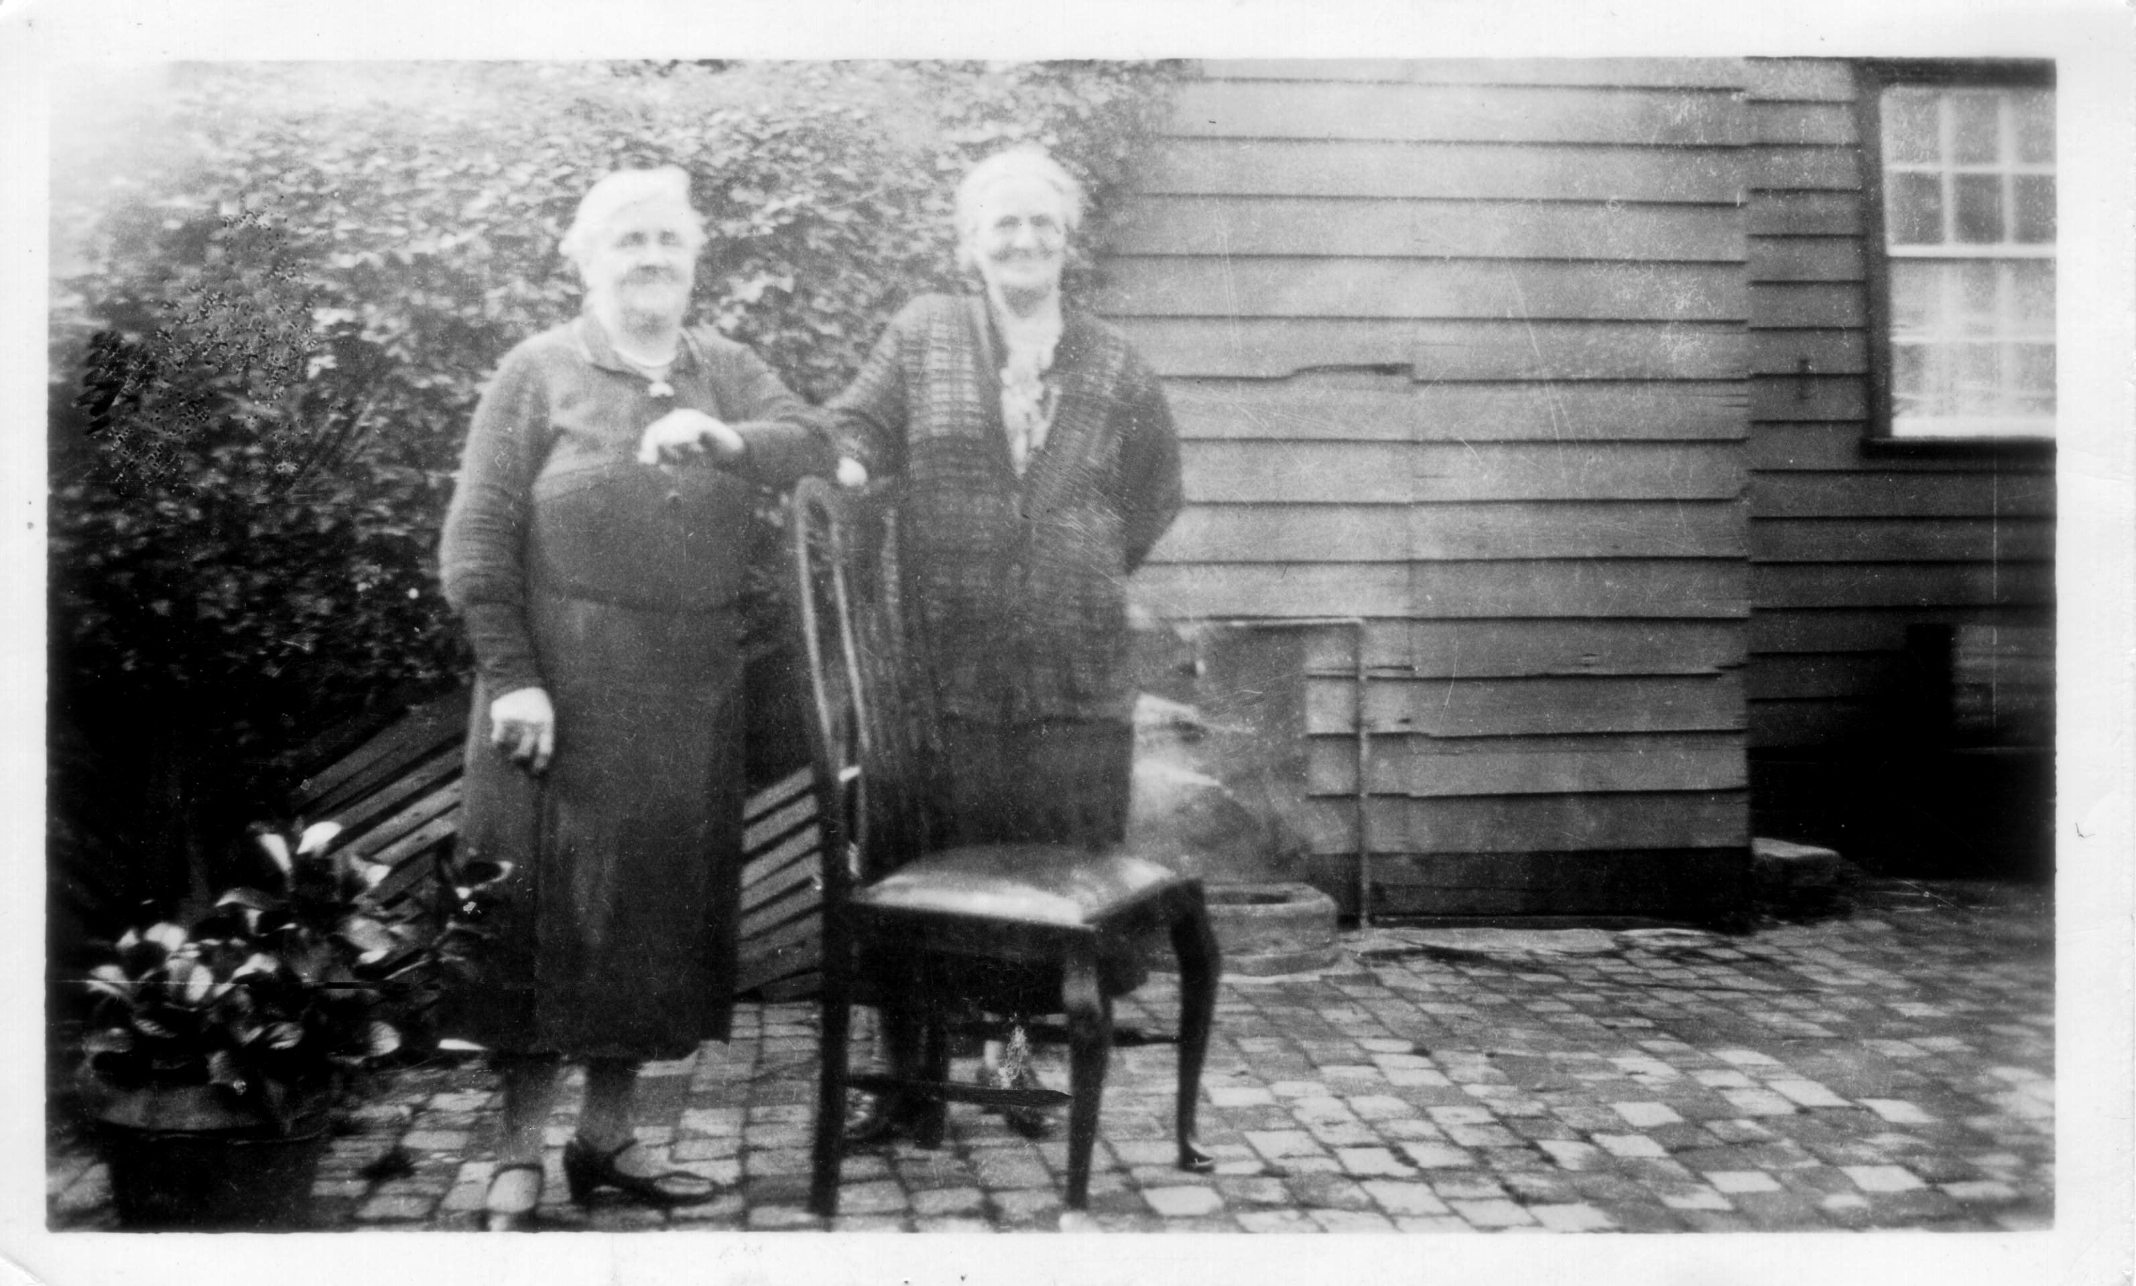
After I left Briar Hill State School, I went to Collingwood Technical School where I learnt my trade of plumbing. I would walk from Greenhills to Greensborough railway station and catch the train to get there. Grandma Hart and Grandma Bishop lived together in a small house in Dennis Street, Northcote at the time, and I would often call in to see them.
Grandma Ada Hart and Grandma Harriet Bishop

When I was around fourteen years of age, I went for my first real job. I travelled from Greensborough by train to Clifton Hill, walked to Fitzroy where I was told that the fellow I was to work with would be at either of two addresses at Ivanhoe. I then travelled to Ivanhoe by bus. On locating the guy, he hung his tool box on the handle bars of his bike, and ‘dinked’ me to the job.
During the 1940’s and into the early 1950’s, there were a number of things that were quite different to the normal way of life. Many items were rationed and you needed coupons to purchase them. Petrol, clothes, food and electricity – which we needed to run the hot water, were all rationed. I could only get three gallons of petrol one month and four gallons of petrol the next month, so once that was gone I used to run my trusty old car on kerosene!

When driving the car at night during the war years, you had to cover the headlights with a metal circle that had a smaller circle cut out in the centre, and an old jam tin cut in half would be placed over that smaller circle, so that the light would only show to the road and not be seen from above. The windows in the house had to be covered with brown paper at night when the lights were on. We could often see the search lights from the Watsonia Army Camp, shining around the sky looking for aircraft.

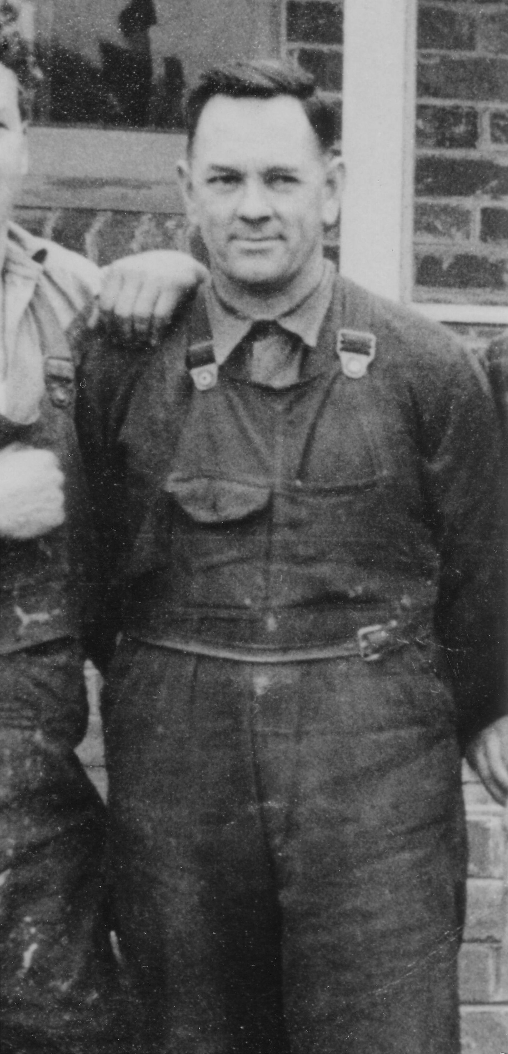
Dad did not have to go to war because as a plumber he was classed an essential service – but he was sent to work in other areas sometimes – Puckapunyal being one that I remember.
At one stage, dad used to ride a Harley motorbike to work – a very old one that used lots of oil! Luckily, Uncle Wilf Bishop worked at Kellow Falkiner Motors in the city, so he would bring home the drums of old oil from car services for dad to put into his motorbike. You had to manage the best way that you could in those days.
Ern Bishop
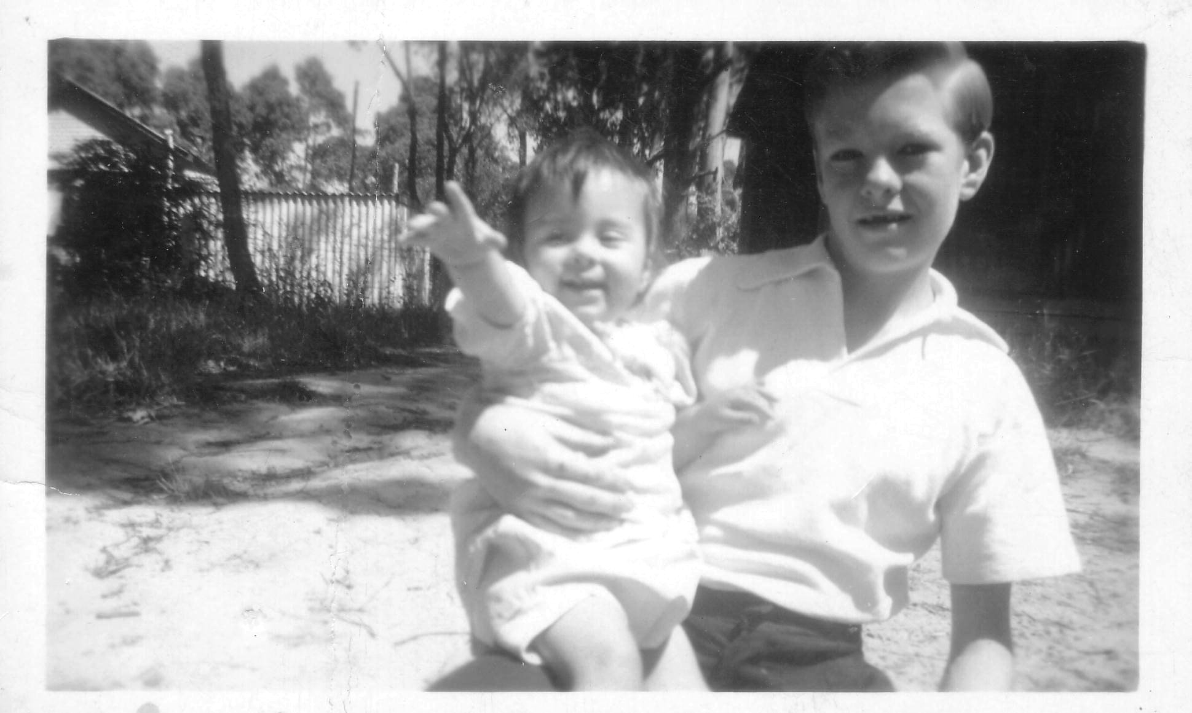
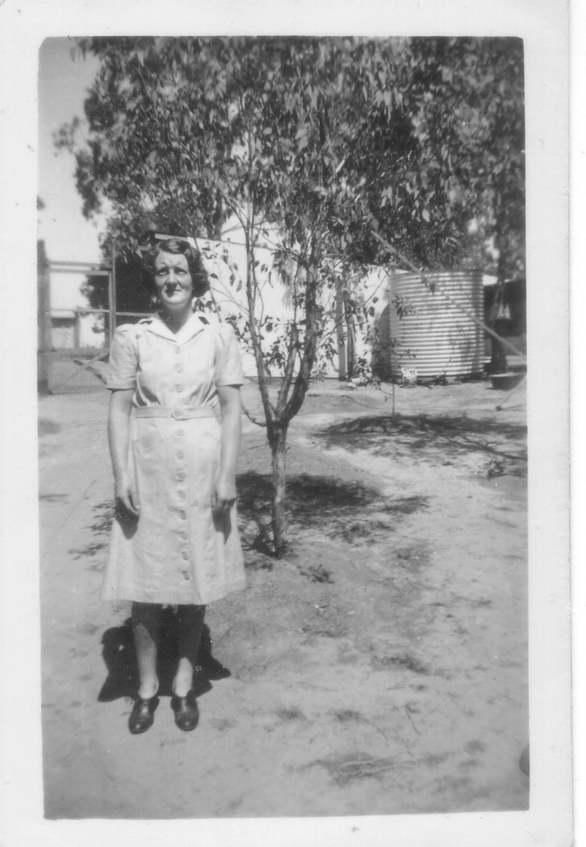
In 1946, my younger sister Glenice was born. Norma and I were both working by then, so we were not at home on weekdays during the daytime to help mum.

Allan and Glenice

Life was extremely busy for Mum at that point, because she not only had a new baby to look after, but she also looked after the chooks and the egg business.

Myrtle in Carnon Street with chook pens in the background
I clearly remember going for my motorbike licence. My mate Ken McKenzie had got his licence not long before I was eligible to go for mine. The policeman just asked Kenny to do a short ride down the street and back. I thought it would be the same scenario for me – not so. As Kenny lived in Briar Hill and I lived in Greenhills, they came under different areas – which meant that I had to go to the city of Melbourne to be tested! All was good and I passed with no problem.

I remember playing football for Greensborough around the late 1940’s and I was a member of the Research Fire brigade for several years, where my future brother in law – Malcolm Parsons also was a member. Mal’s father used to deliver the chook food to us at Carnon Street in Greensborough.

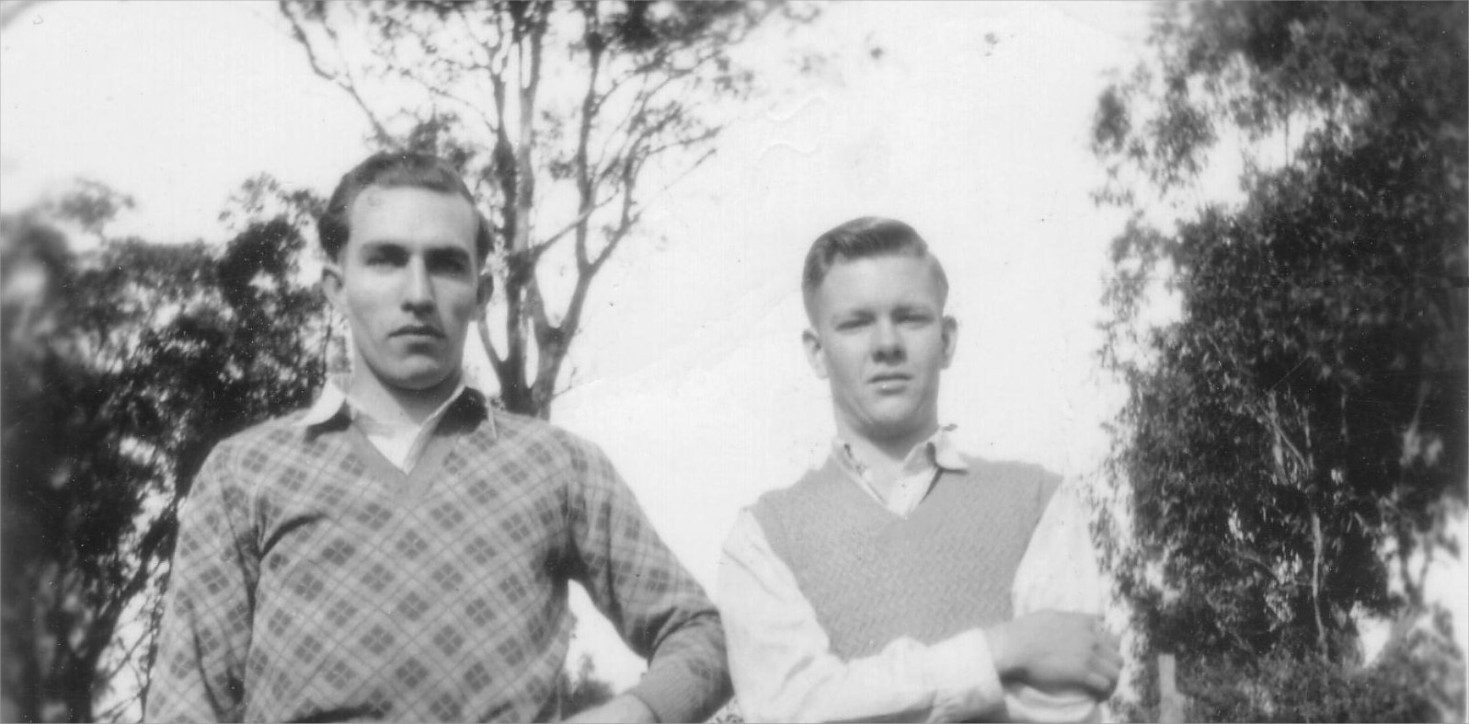
I also had an interest in those early years of competitive running – along with friend Ken McKenzie from Briar Hill and brother in law Jimmy Petts. We went to race meetings mainly at Maribyrnong, but also at Daylesford, Footscray, Werribee and Heidelberg. As I was of small stature in my younger days, I took up boxing as a sport. I remember going with Jimmy Petts to a gym in Fitzroy and Johnny Famechon’s father was there.
Jimmy Petts and Allan Bishop

I also belonged to a Youth Group at Fairfield / Alphington and we would go on various outings with that group. One that I remember was a camp at Warburton, Easter 1949. Norma, Jimmy and I with many friends attended that camp. Everyone would be on roster duty at some stage, but we had a great time!
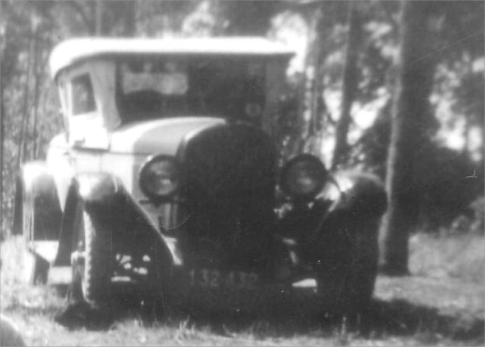
There was one outing that I remember quite clearly. A group of us had gone out together. On the way home one of the cars broke down, so I ended up with eleven people squashed into dad’s Chrysler!! There were people hanging on everywhere, and even some standing on the running boards. There’s no way that you could do anything like that now.

Ern Bishop’s Chrysler

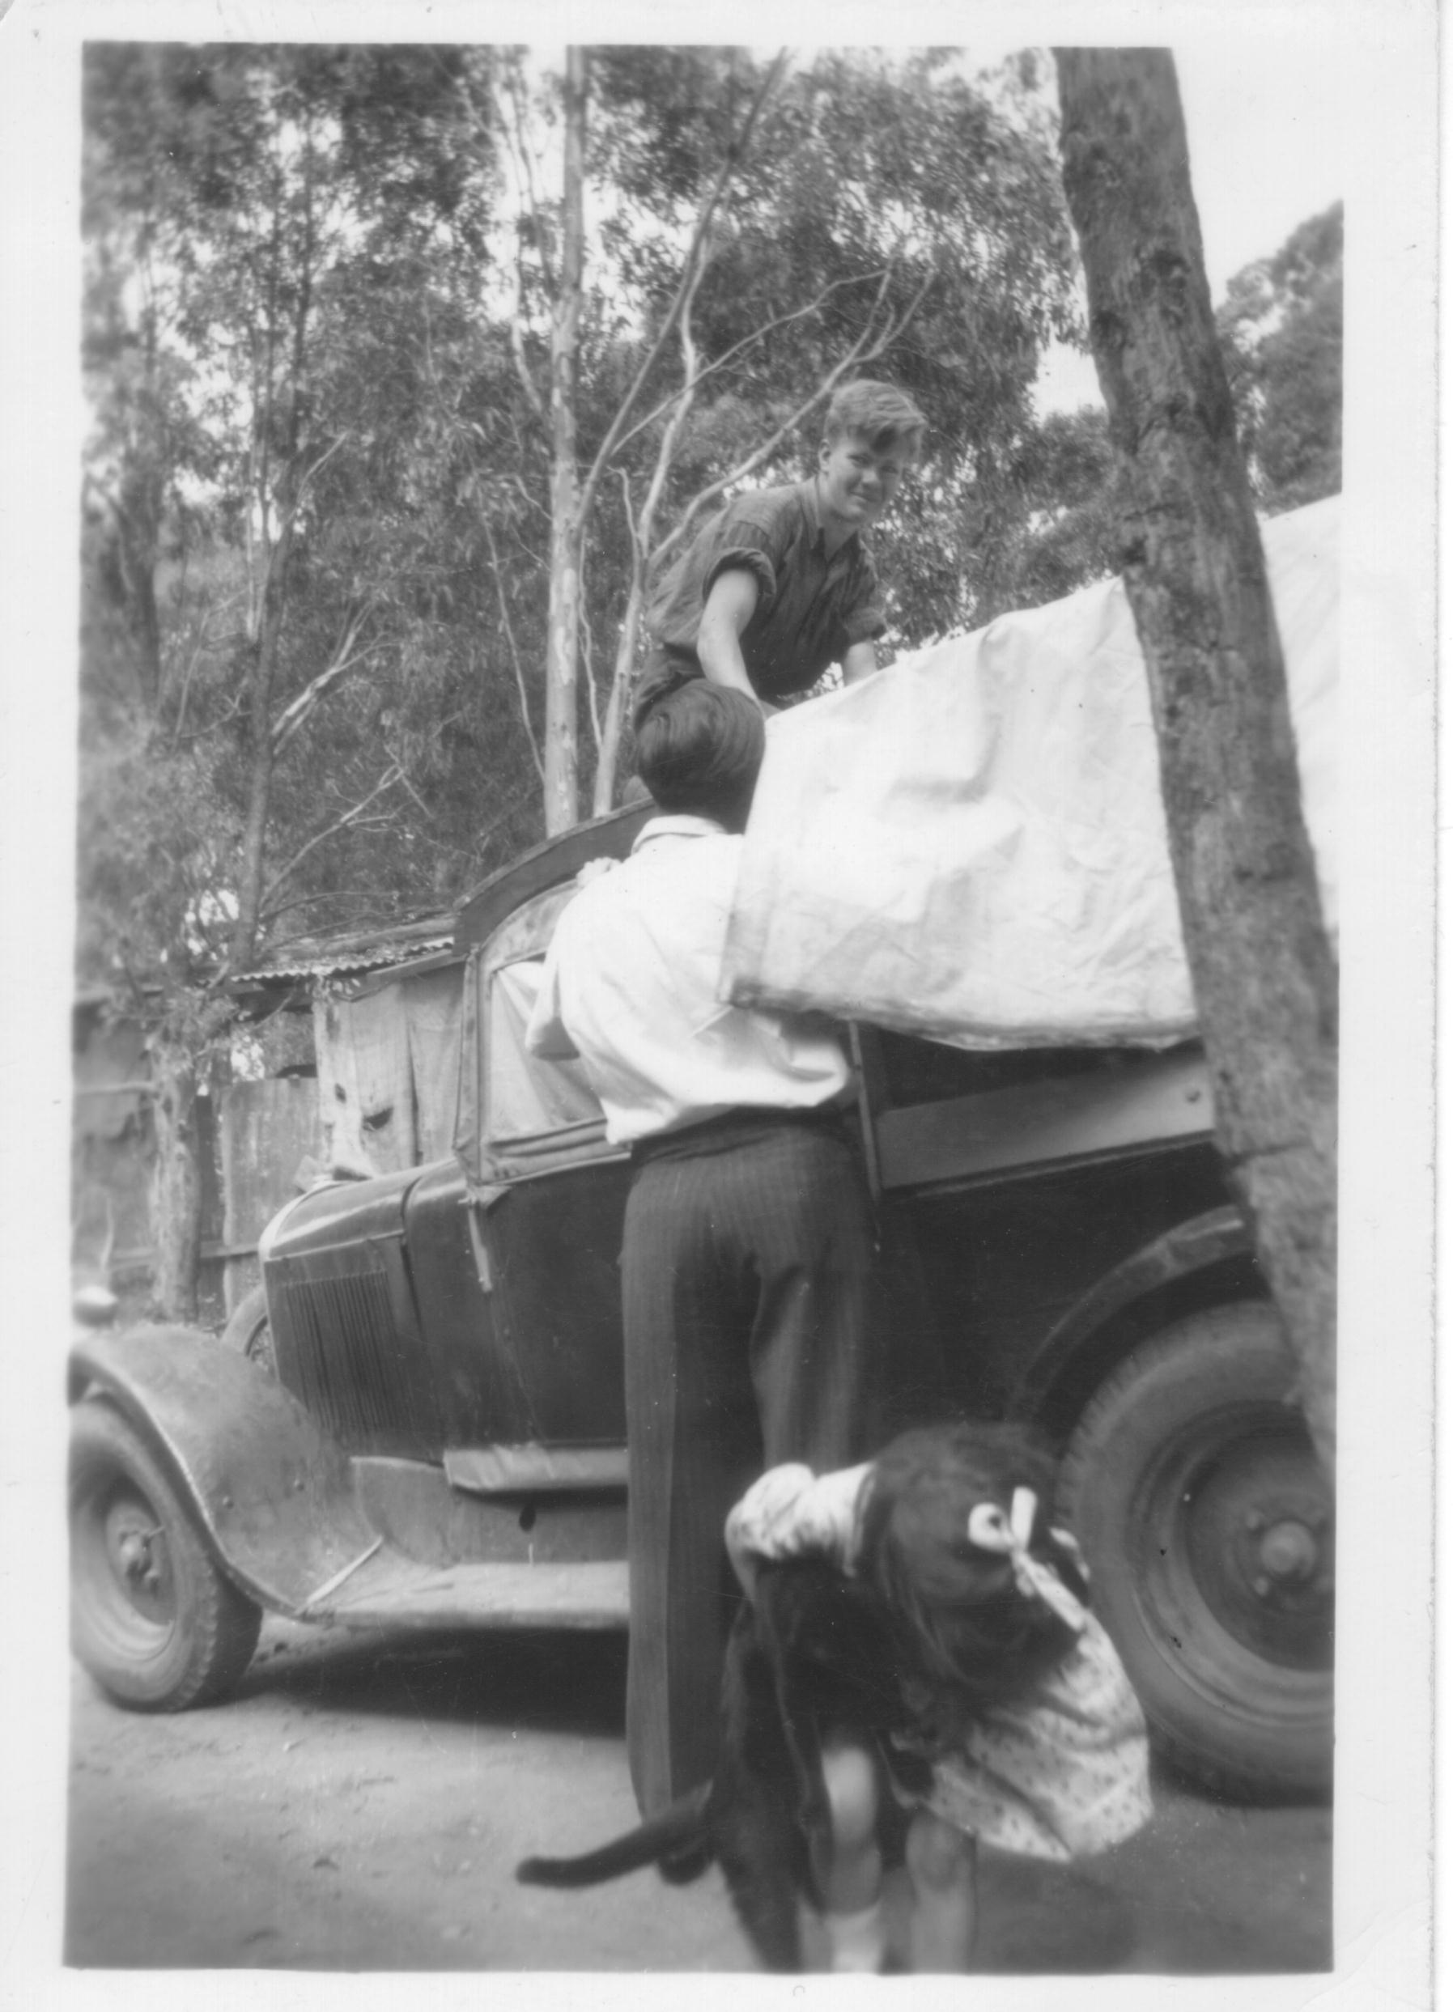
As a teenager, I set myself a goal to aim for – by the time I was twenty-one years old, I wanted to own a car and a block of land. I did achieve both! I purchased my first car – a green ‘Singer’ in 1948 and the block of land at 73 Greenhill Road, Greensborough in 1951. I turned twenty-one in February, 1952. The old Singer was a great car – it had a crank handle to start it, and when windscreen wipers came into being, I had to put one on that was worked by hand from inside the car.
Allan with his Singer

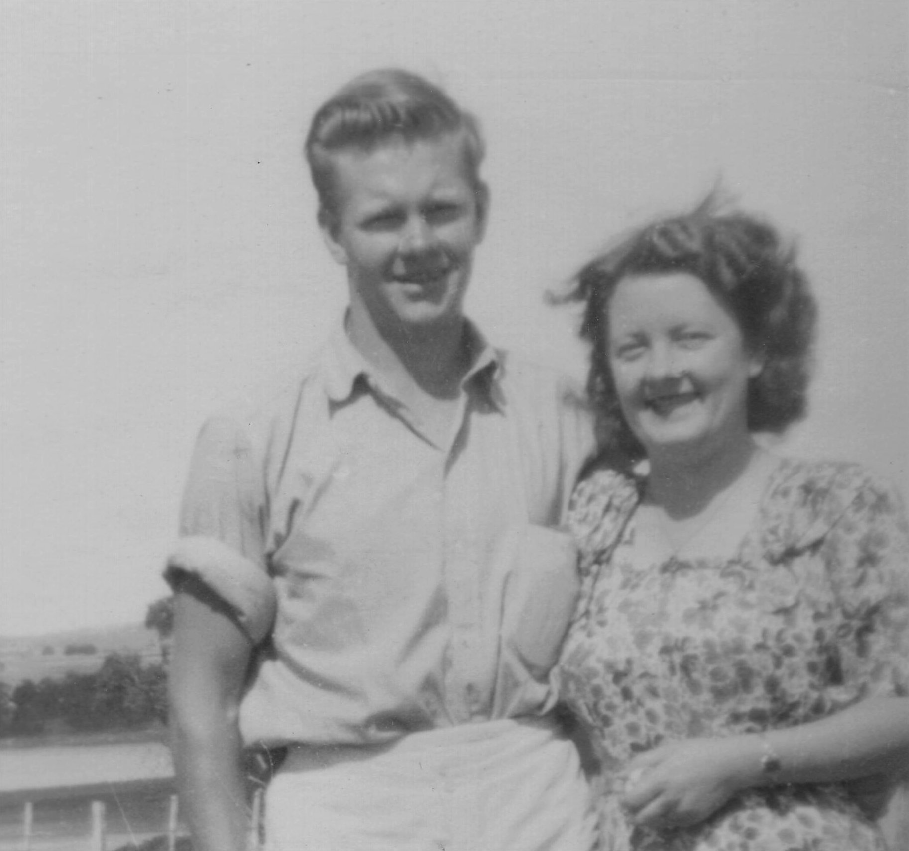

Norma and I regularly went to the local dances at either Lower Plenty Hall or Montmorency Hall.
This is where I met my wife - Shirley Paton. Shirley’s twin sister – Rae Paton, married Malcolm Parsons who I already knew. We all got on really well and spent lots of fun times together.
Allan and Norma Bishop

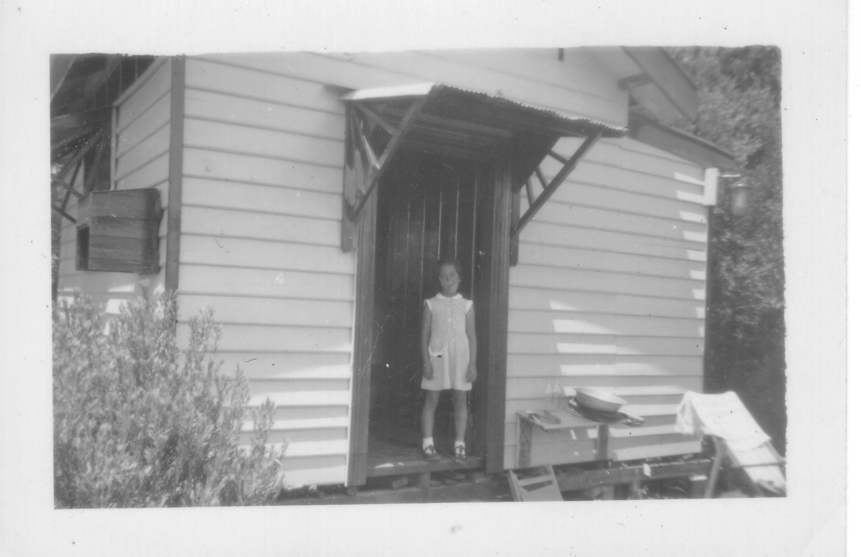
During the 1950’s at Christmas time, many of the family would go to our Uncle Ron and Auntie Ivy Bishops’ holiday place at Rosebud. They had a small bungalow on a block of land in Dalgleish Avenue, Rosebud.
The block was huge and ran right through to Braidwood Avenue. Some of us would sleep in tents; some in the bungalow and there was a caravan for others. New Years Eve was always a fantastic time!
Glenice at Uncle Ron’s bungalow in Rosebud.

Around May 1955, mum, dad, Glenice and I moved to a house in River Avenue, Plenty. I lived in a bungalow near the house. We moved again around 1956 to Memorial Drive, Plenty.
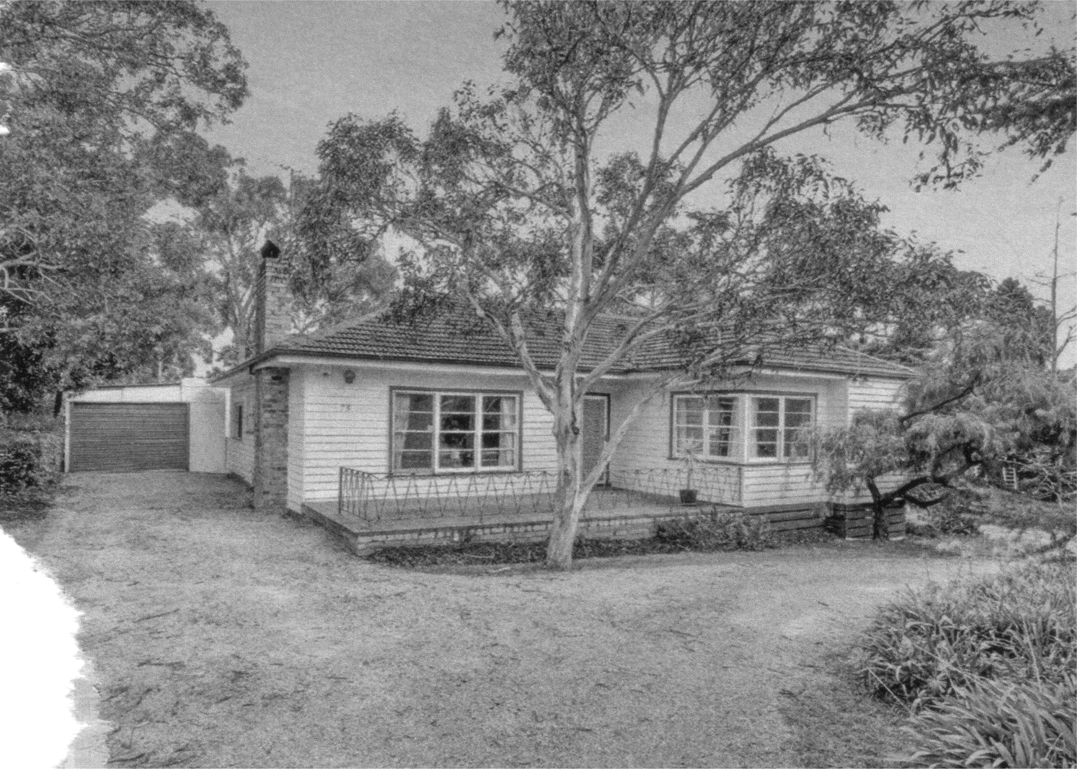

I began building my own home at 73 Greenhill Road, Greensborough in 1956. Also in 1956, dad and I began our plumbing business – E. and A. Bishop – Licensed Plumbers. We worked together until dad retired around 1967.

73 Greenhill Road

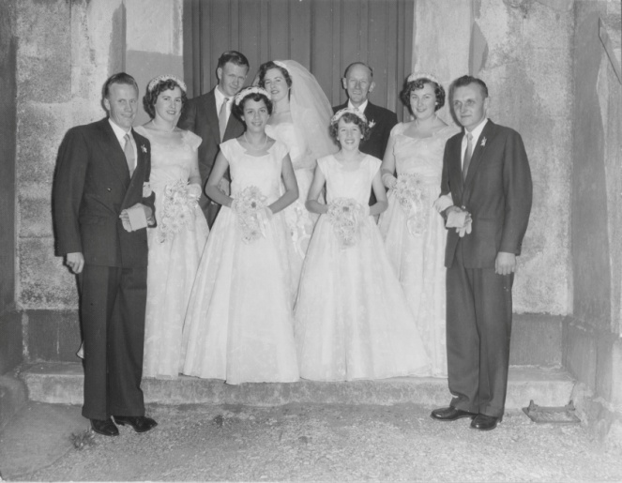
When Shirley and I were married in April 1958, we moved into the house at 73 Greenhill Road. Only the main rooms were completed, and we finished the other rooms as we were able to. My older sister (Norma) and her husband (Jimmy Petts) were living across the road at number 72. In 1962 they moved to a new house that Jimmy built at number 74.

Shirley and Allan’s wedding day

My mum, dad and sister Glenice, moved into number 72 late in 1969. ...so we were all still living very close to each other. We lived at 73 Greenhill Road until December 1977, when Shirley and I together with our four children, moved to our current home in Yarrambat.
Sadly Auntie Shirley passed away on August 24, 2013. Uncle Allan and son, Steven, still live at the home in Yarrambat. It is quite obvious that they enjoy the open space around them.....and they even have electricity, mains water and all modern conveniences! - unlike those early days at Greenhills. However, the memories are something special.
I am truly grateful to have learnt so much about my family and the good, yet often difficult times they faced. It makes me appreciate even more what they have done for us over the years, and I have the utmost respect for all of them.
(Interview with Allan Bishop - by Dawn Bennetts (nee Petts) 2017).

