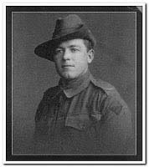

Victor Edwin Splatt

Serial No. 4542

Rank: Private

Unit: 22nd Battalion

Vic Splatt was born at Greensborough on the 7th February 1893, son of Henry (Barl) and Alice Splatt (nee Memmott), he attended Greensborough State School and played cricket and football. He was 22 years 11 months and working as a carter with his father Barl Splatt when he enlisted in the A.I.F.
Vic enlisted on the 22nd January 1916 alongside John Poulter, Reg McDowell, Fred Ely and Fred Chanter, all good mates and all connected in one way or another.

I would love to know the conversation that went on between them that led them all into Melbourne on Saturday the 22nd January 1916 to sign up and become members of the 22nd Battalion, 11th Reinforcements.
Another friend Jim Poulter enlisted in February 1916 and was also in the 22nd Battalion but sadly Jim went onto to become one of Greensborough’s fallen.

Vic embarked on RMS Orontes on 29th March 1916, bound for France.
The 22nd was already in France after fighting in Gallipoli and the Battalion’s first major action was at Pozieres, part of the massive British offensive on the Somme, in September they moved to Ypres sector then back to the Somme for the winter. The Battalion spent most of 1917 bogged in bloody trench warfare from Bullecourt to Broodseinde in Flanders.
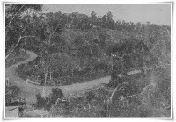
Postcard sent to Victor in France
by his first wife Elsie in 1917.

Elsie's message to Victor
"... we both know there is no place like the borough"

The scene of Greensborough on the front of Elsie's postcard is the corner of St Helena Road and Diamond Creek Road, looking south east.

In 1918 the Battalion returned to the Somme Valley. After helping stop the German Spring offensive in March and April, in the last days of August and September the battalion helped capture Mont St. Quentin. The 22nd Battalion took part in the last action fought by the A.I.F. on the Western Front - the battle of Montbrehain in October 1918.
At 11am on the 11th of November 1918 the guns on the Western Front fell silent.
Every man who served in the 1st World War had their own story to tell, Vic Splatt was wounded in action in 1917 and again in 1918 which led to him being recommended for the Military Medal and was awarded same on 10th June 1918.
“For conspicuous gallantry and devotion to duty during the attack on Ville-sur-Ancre on the morning of the 9th inst. This man was acting as company runner and though wounded whilst advancing onto the enemy position, he remained on duty and refused to go to the R.A.P. He rendered invaluable assistance to his Company Commander in maintaining communication with the Platoon in the advanced posts, passing many times across the most exposed positions under severe M.G. fire. He continued to carry messages and rendered splendid service right through the operation”.
Vic was awarded the Military Medal, British War Medal and Victory Medal.
Vic Splatt returned in 1919 after spending a year in a rehabilitation hospital in England.
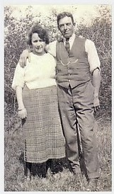
He was able to resume his life in Greensborough until 1926 when he and his wife Violet moved to Oakleigh where they had built a new home, they raised four children and lived in their Oakleigh home for the rest of their lives apart from visits out to Greensborough to keep up with family and I am sure old Army friends. Vic died in 1967 aged 74 years.
Vic and his second wife Violet
Val Wilson (Rolfs)
Great niece of Vic Splatt
April 2011

