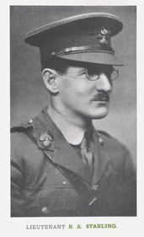
Benjamin Alfred Starling
Service No. n/a
Rank: Second Lieutenant
Unit: London Regiment - Royal Fusiliers
Benjamin Alfred Starling was born in Greensborough in 1878, the son of John Henry Starling (snr) and Jane Gapper. At the time of his enlistment his family was living at Main Street Greensborough where his father was a shopkeeper and post master.
In 1892, Benjamin Starling received a State School scholarship to attend Hawthorn College and later Melbourne University where he completed a Bachelor of Engineering, conferred in 1900. Ben had worked on railways in Gippsland before travelling to Malaysia (Malay Free State) to work on railways there before the outbreak of War. He travelled to England to enlist.
He joined the London Regiment, Royal Fusiliers.
Benjamin Alfred Starling was killed in action 23rd March 1918 France. He is commemorated at Roclincourt Military Cemetery. His death date coincides with the First Battle of the Somme 1918, namely the battle of St Quentin 21st -23rd March 1918.
He was awarded the British War Medal and Victory Medal.
Benjamin Alfred Starling is commemorated in Greensborough on the Fallen Soldier’s Memorial, Greensborough Primary School Honour Board and the Greensborough and District Honour Board at the Greensborough RSL.
After his death, his family received correspondence from a Solicitor in England stating that in his Will, Benjamin had left everything to a widow by the name of Rosina Amelia Taylor. The family was very surprised by this as there had never been any mention of her in any of Benjamin’s letters, although Rosina herself claimed to have been his fiancée for the past three years. Some further research on my part revealed that in 1915, Rosina’s husband had filed for divorce, naming Benjamin Starling as the co-respondent!

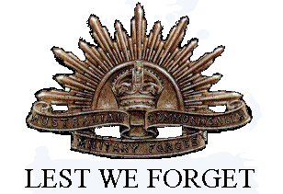
Ben’s older brother John Henry Starling (jnr) was Secretary to the Governor General, transferred to the Prime Minister's Department in February 1912 and was appointed chief clerk in September 1917. He had a distinguished Public Service career.

