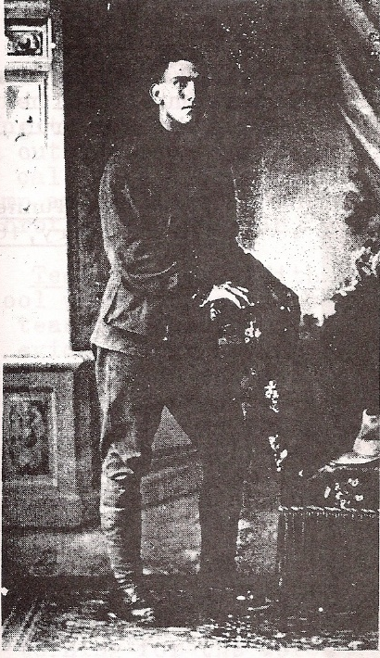
Walter David Starling
Service No. 3004
Rank: Private
Unit: 29th Battalion
Walter David Starling was born in Diamond Creek in 1890, the son of George Davey Starling and Margaret Stewart. He was aged 25 years, 4 months and working as a Motor Driver when he enlisted at Warrnambool on 25th January 1916. His wife Evelyn who also lived at Glenormiston South was given as his next of kin. Walter’s brother Fred Starling from Diamond Creek had already enlisted.
After commencing training, he embarked on HMAT Euripides A14 on 4th April 1916 and landed at Plymouth on 16th June 1916.
On 29th September 1916 he joined the 29th Battalion in France. In early 1917 he had some dental problems that saw him off the line for about 5 days.
Then on 20th April 1918 he was wounded in action with a gunshot wound to his back. This left him paralysed and he was evacuated to England.
He was admitted to the King George Hospital in London where he died on 18th May 1918. He was buried with full military honours in Brookwood Cemetery on 23rd May 1918. His brother Fred Starling DCM, MM was also in attendance as were some English relatives. A report on his funeral is given.
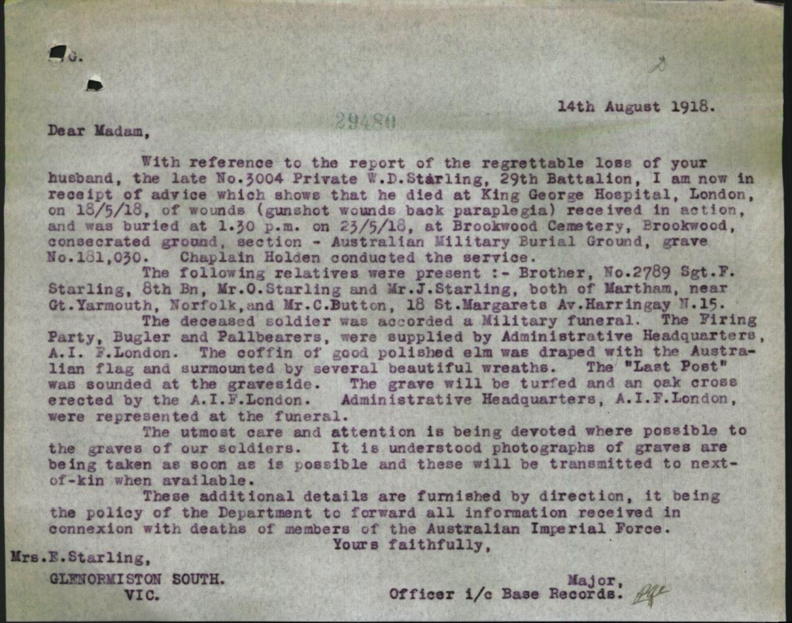
He received the British War Medal, the Victory Medal, the Memorial Plaque and Scroll.

