Frederick George Starling
Service No. 2789
Rank: Lance Corporal
Unit: 8th Battalion
Frederick George Starling was born in Diamond Creek in 1883, the son of George Davey Starling and Margaret Stewart. He was aged 31 years, 8 months and working as an orchardist in Diamond Creek when he enlisted on 16th July 1915.
His father who also lived at Diamond Creek was given as his next of kin.
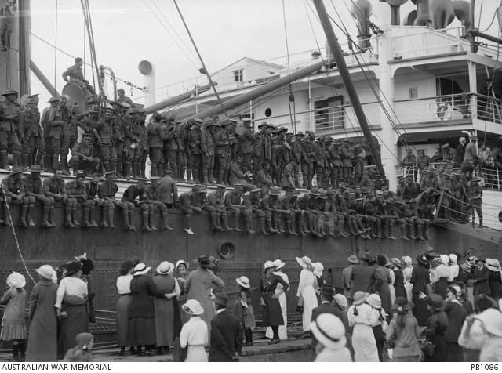
After commencing training he embarked on HMAT Ulysses A38 on 27th October 1915 and arrived in Egypt in November 1915.
On 24th February 1916 he completed his training and was transferred to the 8th Battalion. On 23rd March he 8th left Egypt and disembarked at Marseilles on 31st March 1916 en route to the Western Front.
On 18th August 1916 he was wounded at Pozieres with shell shock and hospitalised at 26th General Hospital. Prior to this he was involved with heavy and gallant action for which he received the Military Medal. The formal order for this was dated 4th October 1916.
He rejoined his unit on 18th January 1917 and was promoted to Lance Corporal on 14th May 1917. On 17th May 1917 he was awarded the Distinguished Conduct Medal. “Pte Starling is a Company Scout and was a member of the attacking party which captured the enemy strong post in front of QUEANT on 22nd April 1917. As he had previously been a member of a patrol who had reconnnoitred and engaged the post he assisted the O.C. in maintaining directions and showed great courage and initiative in finding gaps and leading the way through enemy wire. He continued to do splendid work on entering the post. When the post was being very heavily shelled with concentrated fire he was one of the volunteers who stayed in the danger zone with Captain Yates to observe. Pte Starling was previously awarded the Military Medal for gallant conduct as a runner at Pozieres and is one of the most reliable and courageous men in the Battalion.”
He was later promoted to Temporary Corporal.
On 20th September 1917 he was serving in Belgium and wounded in action with a gunshot wound to his left hand and sent to England for further treatment.
While in England Fred had the sad duty of attending his brother Walter’s funeral on 23rd May 1918.
Fred was repatriated to Australia on the HS Medic D21 arriving on 24th August 1918 and was medically discharged on 28th October 1918. His rank on discharge had been reduced to Lance Corporal.
Frederick George Starling received the Distinguished Conduct Medal, Military Medal, 1914/15 Star, British War Medal and the Victory Medal.
After the war Fred married Jane Eleanor Sims in 1922. Jane was a sister of Sergeant Reginald Emerson Sims KIA and Lieutenant James Frances Sims DCM, MM.
Fred passed away in 1948 at Hampton aged 64.

