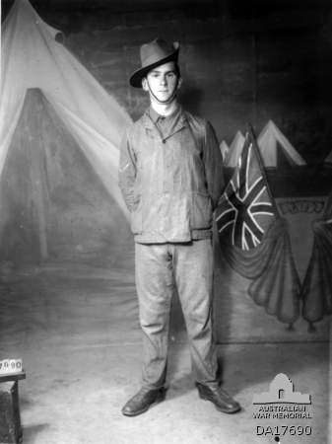
John Stock
Service No. Not Assigned
Rank: Private
Unit: Not assigned
John was born in Greensborough in 1873, his parents were James Stock and Harriet Waller. John was living in Eaglehawk, near Bendigo and employed as a miner when he enlisted on 23rd July 1915, aged 41 years, 7 months. He gave his wife Jane as next of kin.
John was declared medically unfit as he was deaf in one ear and had lung problems. He received his medical discharge on 14th September 1915.
The examining doctor was E R Cordner, who would later to move to Greensborough.

