William James Stock
Service No. 19724
Rank: Gunner
Unit: 8th Field Artillery Brigade & 7th Field Artillery Brigade
William James Stock was born in Melbourne in 1893, the son of Frederick Charles Stock and Mary Chalmers Main. At the time of his enlistment the family was living at Gardenvale. He was 22 years and 8 months old and working as a plumber and gasfitter when he enlisted on 8th July 1915. His next of kin was his wife Mrs. Emma Stock.
He had previously served 5 years in the Victorian Scottish Regiment.
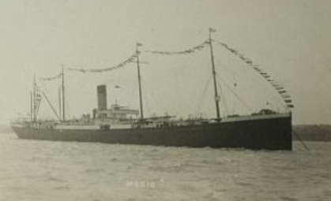
After training he embarked on HMAT Medic on 20th May 1916 and landed in Plymouth on 18th July 1916.
After completing training in England he was taken on strength in the 8th Field Artillery Battalion on 30th December 1916 and saw active service on the Western Front in France.
In early 1917 William served 2 months at the 2nd ANZAC Headquarters and then another month at the 3rd ANZAC Artillery course. After serving again with the 8th Field Artillery Brigade he was transferred to the 7th Field Artillery Brigade in September 1917.
On 20th October 1917 he was admitted to hospital with appendicitis. He was later evacuated to England and remained in hospitals for the rest of his service.
On 15th April 1918, he embarked for Australia on the HMAT Marathon A74 with gastritis arriving on 12th June 1918 and he received a medical discharge on 18th July 1918.
He received the British War Medal and the Victory Medal.
Will passed away in 1970 aged 77.
William Stock is remembered on the Greensborough Primary School Honour Board.
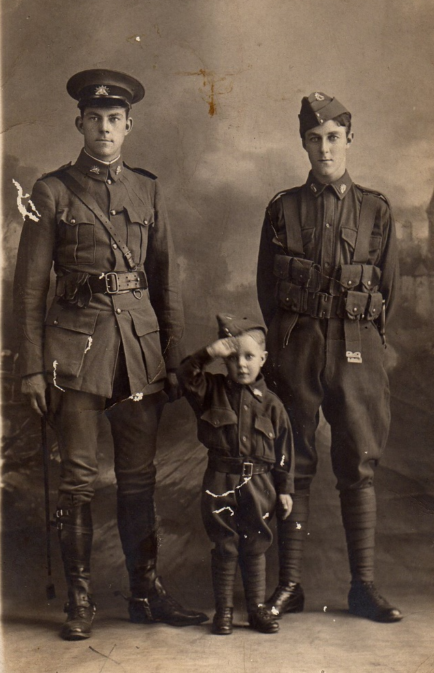

Stock brothers

