Robert Morton Tait
Service No. 761
Rank: Lance Corporal
Unit: 31st Battalion
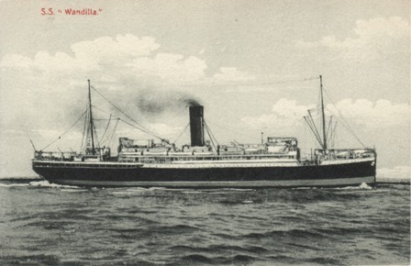
Robert Morton Tait was born in Ringwood in 1895, the son of Henry Cameron Angus Tait and Margaret Morton. At the time of his enlistment the family was living at Lilydale. He was 20 years and 6 months old and working as a Carpenter when he enlisted on 28th June 1915. His next of kin was his mother, Mrs. Margaret Tait of Lilydale.

After training he embarked on HMAT Wandilla on 9th November 1915 and landed in France. He was taken on strength in the 31st Battalion and saw active service on the Western Front in France.

On 27th October 1916 Robert was wounded, suffering from severe shell shock. He embarked from Calais to Hospital in England. He later received a medical discharge due to shell shock. He was returned to Australia on the HT Barambah on 31st July 1918.
Robert Morton Tait received the 1914/15 Star, British War Medal and the Victory Medal.
Robert married Sylvia Decima Currie in 1926 and later lived at Alexander Street Greensborough.
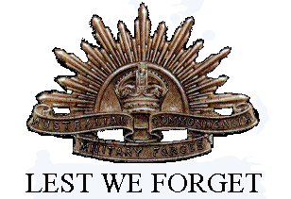
Robert Tait passed away 6th July 1942 in Greensborough, age 47. He was buried at St. Katherine’s Cemetery, St Helena.
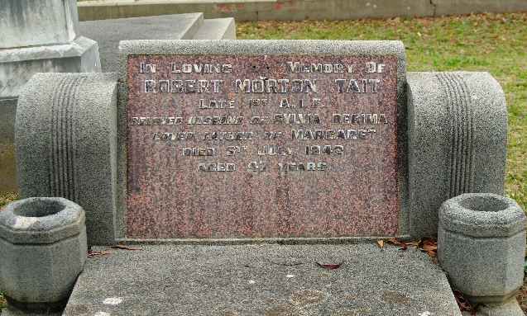
A Report of Robert Tait’s death was found in the Eltham & Whittlesea Advertiser Friday 10th July 1942:
“The death occurred on Monday last of Mr. Robert Morton Tait, of Alexandra Street Greensborough. Mr. Tait, who had retired from his employment with the Railways Department, served overseas with the 31st Batt. A.I.F. in the 1914-18 war. He is survived by Mrs. Tait and one daughter, Miss Margaret Tait. There was a large attendance at the funeral which took place at the St. Helena Cemetery on Tuesday. The services in the church and at the graveside were conducted by the Rev. A. T. Roberts and Rev. Temphany. The Masonic Service was read by Mr. A. Lowerson, and the Returned Soldiers' Service by Mr. Andrew.”

