Vivian Thomas
Service No. 255
Rank: Driver
Unit: 23rd Battalion, 3rd Field Artillery Battalion
Vivian Thomas was born in Burnley in 1899, the son of Charles Thomas and Gerte Atchison. At the time of enlistment he was living at Eltham. He claimed to be 18 years and 2 months old and working as a farm hand when he enlisted on 22nd February 1915.
However the records state he was born 1899 and thus would have been 16 years of age and the signature on his father's permission is very similar to his own.
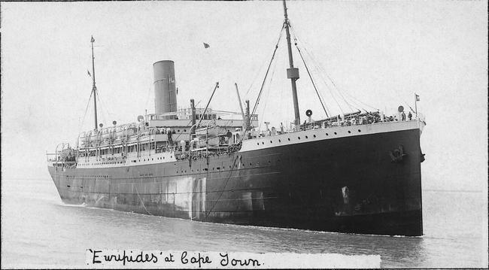
After training Vivian embarked on HMAT Euripedes A14 on 10th May 1915 and landed in Egypt. He was taken on strength in the 23rd Battalion on 13th January 1916. He embarked for the Western Front on 19th March 1916.
On 17th June1916 he was transferred to 3rd Field Artillery Battalion.
During 1917 and 1918 a number of misdemeanors saw him lose pay on a few occasions. In September 1918 he was hospitalised with ulcers.
Vivian Thomas returned to Australia on the Cluny Castle on 21st May 1919 and was discharged on 23rd August 1919.
He received the 1914/15 Star, British War Medal and the Victory Medal.
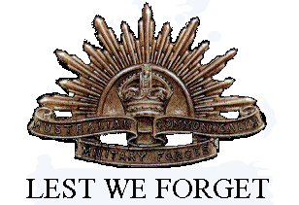
Vivian Thomas is commemorated on the Greensborough and District Honor Board at the Greensborough RSL.
In 1939 he married Kathleen Tresize.

