William Henry Thomas

Service No. 1742

Rank: Private

Unit: 60th Battalion & 59th Battalion

William Henry Thomas was born in Fitzroy in 1876, the son of William Thomas and Charlotte Berwick. At the time of enlistment he was living at Easey Street, Collingwood. He was 38 years and 9 months old and working in the boot trade when he enlisted on 14th August 1915.

His wife May Sophia Thomas (nee Davies) was listed as next of kin.

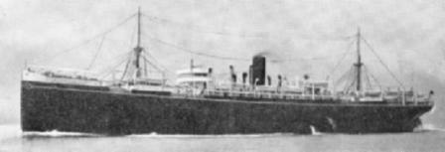

After training William embarked on HMAT Port Lincoln A17 on 4th May 1916 and landed in Egypt.

He was transferred to France and taken on strength in the 60th Battalion on 11th November 1916.

On 25th September 1918 he was transferred to 59th Battalion.

William Thomas returned to Australia on the Warwickshire on 28th May 1919 and was discharged on 12th July 1919.

He received the British War Medal and the Victory Medal.

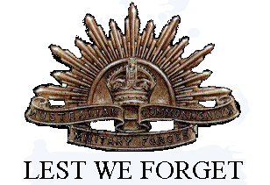William Henry Thomas is commemorated on the Greensborough and District Honor Board at the Greensborough RSL.

In 1924 his postal address was C/O Greensborough Post Office.