Enos John Tinham (aka Enos John Timkem)
Serial No. 1600
Rank: Private
Unit: 3rd Pioneer Battalion
Enos John Tinham was born in 1875 in Greensborough, the son of Enos Tinham. In 1899 married Theresa Levenia King under the name of Evans John Tinham.
At the time of his initial enlistment the family was living at 11 Bridge Street, Port Melbourne. He was 39 years old 9 months and working as a Labourer when he enlisted on 14 July 1915. This enlistment was cut short due to his wife Teresa being ill and he was discharged on 30th November 1915.
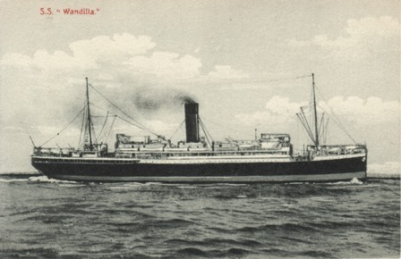
He enlisted for a second time on 19th February 1916, Serial No. 1600. He was 40 years 5 months old. His next of kin was his wife living at Hoddle Street Abbotsford.
After training he embarked on HMAT Wandilla A62 on 6th June 1916 and landed in England on 26th July 1916. He was taken on strength in the 3rd Pioneer Battalion on 29th January 1917 and saw active service on the Western Front in France. On 8th August 1917 he was transferred to the Australian Veterinary Corps Hospital.
During a stopover in Cape Town, Enos was absent without leave for 6 hours and was forfeited 1 day’s pay. Throughout his time on active service Enos was hospitalized with various ailments including influenza.
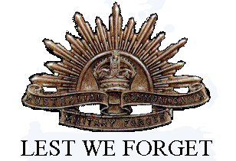
Enos Tinham is commemorated in Greensborough on the Greensborough and District Honour Board at the Greensborough RSL; however, he appears as E.J.Timkem.
Enos’ son William Tinham served with 31st Battalion and was taken as a Prisoner of War in Belgium and interred at Limberg Camp in Germany. His stepson Reginald Gordon Tinham also served and was with the Naval Bridging Train.
Enos passed away on 18th August 1955 in Heidelberg and Teresa in 1946 in Port Melbourne

