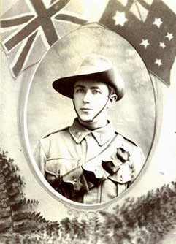Harold Turner

Service No. 8240

Rank: Private

Unit:  Australian Army Service Corps & 2nd Field Bakery

Harold Turner was born in Stebbing, Essex, England in 1891, the son of George Turner and Charlotte Caroline Parchment. At the time of his enlistment the family was living at Eltham Road, Greensborough. He was 24 years 9 months and working as a Baker when he enlisted on 6th July 1915.

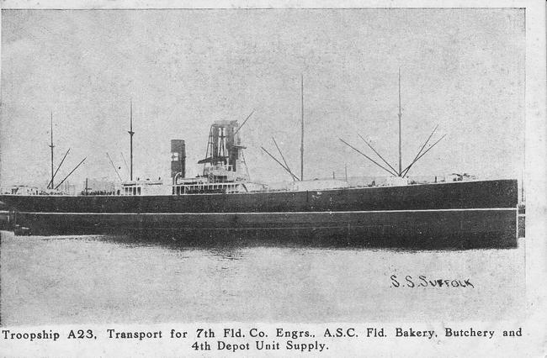Harold named his father Mr. George Turner as next of kin.

After training he embarked on HMAT Suffolk A23 on 30th November 1915 destined for Egypt.

On 17th March 1916 he embarked for Marseilles and landed in France on 23rd March.

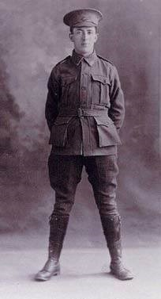During 1916 and 1917 he had a number of hospital stays with diarrhea and tonsillitis and a bout of influenza in 1918.

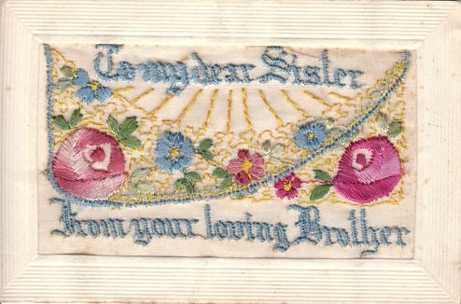In a birthday card to his sister in September 1917, Harold wrote: “…My word we are getting a fairly lively time of it over here now with the Hun raiders they were over three or four times last week and did a terrible lot of damage and killed a lot of people. I am just having two days off now to get inoculated against fever…”

He returned to Australia on the Zealandia on 28th June 1919 and was discharged on 5th October 1919.

He received the British War Medal and the Victory Medal. Harold Turner is commemorated on the Greensborough District Honor Roll at the Greensborough RSL.

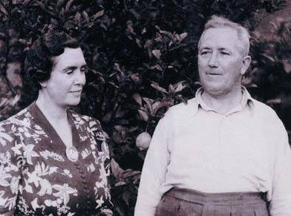

In 1938 Harold married Frances Virginie (Gina) Smith a widow who owned the Greensborough Hotel.

