Clarence Alexander Watson

Service No. 2695

Rank: Private

Unit: 7th Battalion 59th, 3rd Division Headquarters, 1st Australian Division Headquarters, AIF Depot.

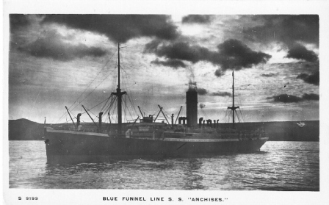Clarence Alexander Watson was born in Greensborough in 1895, the son of Robert Reid Watson and Janet Woods. At the time of his enlistment the family was living at Urquhart Street Northcote. He was 19 years old and working as a Farmer when he enlisted on 9th June 1915. He named his father as Next of Kin.

After training he embarked on HMAT Anchises A68 on 26th August 1915 and landed in Egypt. He was taken on strength in the 7th Battalion and saw active service in Gallipoli. He served as a Batman to Lt Col Weick.

He was later transferred to serve at Mudros on Lemnos. On 24th February 1916 he was transferred to the 59th Battalion at Tel El Kebir in Egypt.

On 3rd March 1916 he transferred to 15th Brigade HQ and on 25th June 1916 he disembarked at Marseilles.

On 30th May 1917 he was married in England to Harriett Annie Lewis.

On 16th November 1917 he was transferred to the 3rd Division HQ and to the 1st Division HQ on 16th May 1918. On 13th July 1918 he transferred to the AIF Depot.

He returned to Australia on the “Main” on 11th October 1919 and was discharged on 10th December 1919.

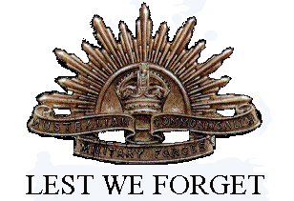He received the 1914/15 Star, British War Medal and the Victory Medal.

Clarence Alexander Watson is commemorated on the Greensborough State School Honor Board.

His brother Percy Drysdale Watson (service no. 2414) also served in World War 1.