Isaac Albert Watson
Service No. 1310
Rank: Private
Unit: 10th Australian Mobile Veterinary Section, Army Veterinary Corps.
Isaac Albert Watson was born in Cooktown, Queensland on 19th April 1885, the son of Robert Watson and Hannah Elliot. At the time of his enlistment the family was living at Greensborough. Isaac married Emily Crosling in 1905, his next of kin was his wife, Mrs. Emily Watson of Greensborough. He was 32 years and 4 months old and working as a Groom when he enlisted on 4th September 1917.
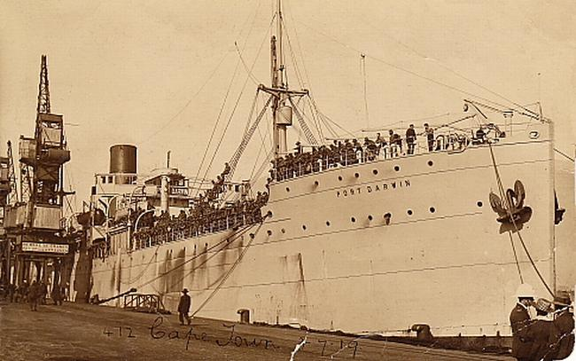
After training he embarked on SS Port Darwin on 30th April 1918 and landed in Egypt. He was taken on strength (July 19th) in the 10th Australian Mobile Veterinary Section in Surapend and saw active service in Egypt.
Isaac was transferred to hospital shortly after arrival and was invalided out with Asthma. He returned to Australia on the Wiltshire on 30th August 1918.
Isaac Albert Watson received the British War Medal and the Victory Medal.
Isaac passed away 29th August, 1940 and Emily 1965.

