Percy Drysdale Reid Watson
Service No. 2414
Rank: Private
Unit: 3rd Pioneers
Percy Drysdale Reid Watson was born in Greensborough in 1892, the son of Robert Reid Watson and Janet Woods. At the time of his enlistment the family was living at Rozelle, NSW. He was 23 years and 8 months old and working as a Driver when he enlisted on 31st May 1916. His next of kin was his wife Ruby Adelaide Watson. Percy married Ruby Adelaide Dredge in 1911 in Victoria.
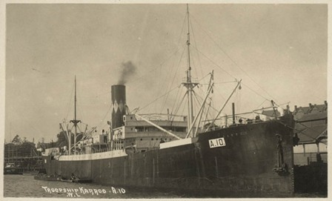
After training he embarked on HMAT Karroo A10 on 18th September 1916 and landed at Plymouth on 16th November 1916. After completing his training in England, he went to France on 10th April 1917.
He was taken on strength in the 3rd Pioneer Battalion and saw active service on the Western Front in France. In July 1918 he was hospitalised and invalided to England suffering nephritis.
He returned to Australia for on the Suevic on 5th January 1919. He was discharged on 15th February 1919.
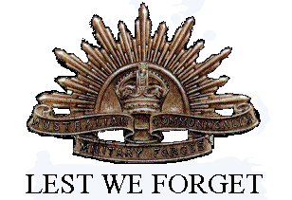
He received the British War Medal and the Victory Medal.
Percy Watson is commemorated on the Greensborough State School Honor Board.
Sadly, Percy passed away in 1958 at Whittlesea.
Percy’s brother Clarence (Service no. 2695) also served in World War 1.

