Richard Lewis Weir
Service No. 537
Rank: Private to 2nd Lieutenant
Unit: 21st Battalion
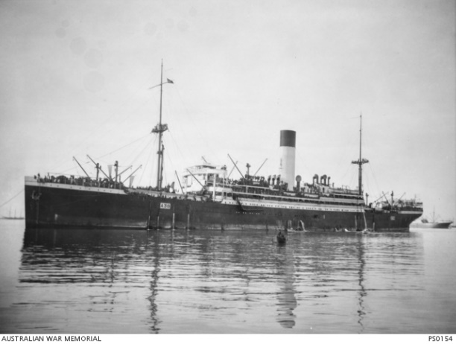
Richard Lewis Weir was born in 1894 in Northcote, the son of Adam Weir and Ellen Potter. His next of kin Catherine O. (Crosswell) Weir was his step mother. At the time of his enlistment the family was living at Bundoora. He was 20 years old and working as a farmer when he enlisted on 28th September 1914. His father died in March 1915, six weeks before Richard embarked.
After training he travelled on HMAT Ulysses A38 and landed in Gallipoli on 29th August 1915. He was taken on strength and saw active service in Gallipoli and France.
In November 1915, Richard was admitted to hospital for a week suffering influenza. When recovered he proceeded to join the British Expeditionary Force and disembarked in Marseilles in March 1916. From December 1916, Weir was promoted through the ranks to Corporal (1st February) and Sergeant (16th May). Following hospitalization in France with scabies in August 1916, he was granted a 10 day furlough to England. In November 1917, he was awarded the Distinguished Conduct Medal and selected to attend officer training in England. He qualified as an officer in May 1918 and was appointed 2nd Lieutenant. He proceeded to France in June 1918 and awarded a Military Cross in July 1918.
The citations for his Distinguished Conduct Medal in November 1917 and the Military Cross in September 1918 follow:
Sgt Richard Lewis Weir, 14th October 1917: “For conspicuous gallantry at Broodseinde on Oct.9th. After all Officers had become casualties, this NCO immediately took charge and collected his men who had become very scattered and led an attack on an enemy machine gun position on the edge of Daisy Wood which was holding up the company. After putting this gun out of action he led his men to a position north east of Daisy Wood and established there until relieved by the 49th Battalion on the night of 9/10 Oct.” (Brigadier- General J. Paton)
2nd Lieut Richard Lewis Weir: 8th July 1918: “Near Villers Bretonneux on the morning of 4th July this officer led his platoon during the attack. On reaching the objective his command being harassed by snipers and machine gun fire from a small system of enemy trench; he crawled out in broad daylight and reconnoitered the position with a view of mopping it up. He then organised his rifle grenadiers and with the assistance of a trench mortar forced the enemy to withdraw. In the evening he led his platoon against this trench system occupied it, killing 7 of the enemy and capturing one machine gun. The following morning in the face of machine gun fire he pushed out new posts. This officer displayed great dash and courage.” (Brigadier-General C.H.Brand)
Richard Lewis Weir was killed in action 26th July 1918 at Villers Brettoneux. He is buried at Villers Brettoneux Military Cemetery.
Red Cross records provide the following eye witness account of his death: ‘"I saw Lieut. Dick Weir of A.I. hit in the stomach in front of Villers Bretonneux at night (about 10-10.30 p.m.) whilst leading a fatigue party at the time. He was carried back by two of the men to the R.A.P. and died on the stretcher on arrival there. He was buried at the Austral Military Cemetery and a cross and head stone were erected. The news of him [being] awarded the ‘M.C.’ came through on the night he was killed. Lieut Weir was a fine fellow and a good soldier, well-liked by the men". (M. J. W. Irwin, 186, 21 Battn. A. Coy)
Richard Lewis Weir was awarded a Military Cross, Distinguished Conduct Medal, the 1914/15 Star, British War Medal, Victory Medal, Memorial Plaque and Scroll.
In 1968 his brother Alexander Weir applied for Richard’s Gallipoli Medal.
Richard Weir is commemorated in Greensborough on the Fallen Soldier’s Memorial and Greensborough Primary School Honour Board.
