Trevor Crosswell Weir
Service No: 39721
Rank: Gunner
Unit: 12th Field Artillery Brigade
Trevor Crosswell Weir was born in Bundoora in December 1899, the son of William Adam Weir and Catherine Otto Crosswell. At the time of his enlistment the family was living at “Ulupna” Bundoora. He was 18 years old and working as a Farmer when he enlisted on 24th December 1917. Trevor named his mother Mrs. Catherine Weir as his next of kin, as his father William passed away in 1915.
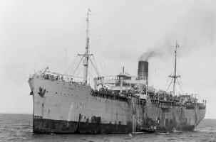
After initial training he embarked on SS Port Darwin on 30th April 1918 and landed in Suez on 7th June 1918. He left there on 7th July and arrived in Southampton on 16th July.
After completing training in England, he was sent to France on 17th October 1918. Here he was taken on strength in the 12th FAB, specifically to the 45th Battery.
Trevor returned to Australia on the HT City of Exeter on 24th August 1919.
He received the British War Medal and the Victory Medal.
Trevor Weir is commemorated on the Greensborough State School Honor Board.
Trevor’s brother Richard (Service no. 537) was killed in action on 26th July 1918 & stepbrother William (Service no.137) also served in World War 1.
Sadly, Trevor passed away in 1962.
