William Gordon Weir
Service No. 137
Rank: Driver
Unit: 10th Machine Gun Company & 3rd Machine Gun Battalion
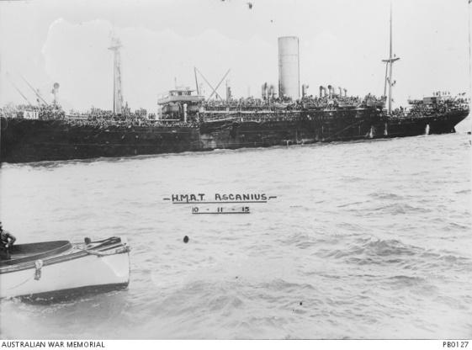
William Gordon Weir was born in Whittlesea/Bundoora in 1889, the son of William Adam Weir and Ellen “Nell” Potter. At the time of his enlistment his address was Oaklands, NSW.
He was 26 years and 10 months old and working as a Farmer when he enlisted on 2nd March 1916. William named his sister Mrs. Ruby Louisa Lambell of Willow Grove, Gippsland, as his next of kin. Both parents had passed away.
After training he embarked on HMAT Ascanius A11 on 27 May 1916 and landed in in Devonport on 18th July 1916. He then completed his training in England.
He was sent to France on 22nd November 1916 and taken on strength in the 10th Machine Gun Coy. In July 1918 his unit was redesignated into the 3rd Machine Gun Battalion. All his war service was in France.
William married Helen in Calais, France on 15th May 1919. They both returned to Australia on the Canberra on 11th September 1919.
He received the British War Medal and the Victory Medal.
William Weir is commemorated on the Greensborough State School Honor Board.
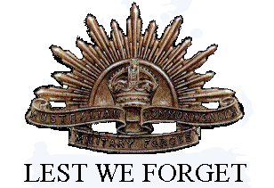
In the depression William was farming at Moyhu in the King Valley of Victoria. The property was called “Kooringal Park”.
Williams’s two stepbrothers Trevor (Service no.39721) and Richard (Service no.537) served in World War 1. Richard Weir was killed in action in 1918.
Sadly, William passed in 1965 and Helen in 1978.

