William John Ewart White
Service No. 27497
Rank: Temp. Corporal.
Unit: 4th Division Ammunition Column (DAC), 110th Howitzer Battery
William John Ewart White was born in Elsternwick on the 26th September, 1897, the only son of William Henry George White and Alice Matilda Ewart. At the time of his enlistment he was living at “Riverside” Greensborough. His next of kin was his mother Mrs. Alice Matilda White of Glenhuntly Road, Elsternwick. He was 18 years and 9 months old and working as a Surveyor’s Assistant when he enlisted on 9th May 1916.
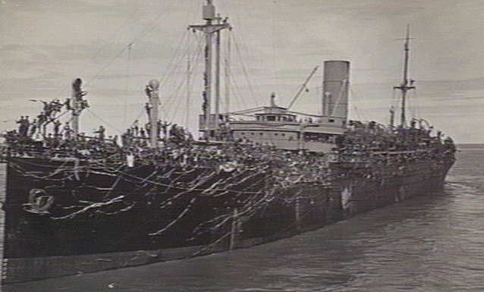
After training he embarked on HMAT Borda A30 on 20th October 1916 and landed in Plymouth on 9th January 1917.
He was sent to France on 9th August 1917 and taken on strength in the 4th Division Ammunition Column as a Gunner. On 8th November 1917 he was transferred to the 10th Field Artillery Brigade.
On 31st July 1918 he was sent to Signals School and rejoined his unit on 13th September 1918. On 14th March 1919 he was promoted to Temporary Corporal.
William returned to Australia on the “China” on 8th June 1919 and was discharged in August 1919. He received the British War Medal and the Victory Medal.
William is commemorated on the Greensborough District Honor Board at the Greensborough RSL and Greensborough State School Honor Roll.
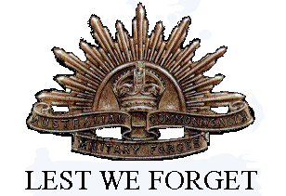
Immediately post-war, William lived in Greensborough and worked as a surveyor. William married Kathleen Frances Muntz in Malvern on 20th September 1926.
During World War 2, William’s house in Darwin was bombed on 19th February, 1942, losing his Discharge Certificate. They later moved to Queensland.
Sadly William passed away 16th December, 1986, aged 89.

