Albert Cecil Whitlocke
Service No. 941
Rank: Private
Unit: 14th Battalion
Albert Whitlocke was born in Earsfield, England in 1896, the son of Francis Oliver Whitlocke and Ruth Alldritt. At the time of his enlistment the family was living at Grace Park, Greensborough. He was 19 years old and working as a Motor Mechanic and Driver when he enlisted on 1st October, 1914. Next of kin was his father Mr Francis Oliver Whitlocke.
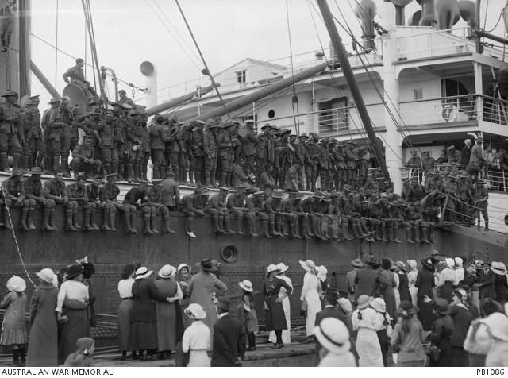
After training he embarked on HMAT Ulysses A38 on 22nd December 1914 and landed in Egypt. He was taken on strength in the 14th Battalion and saw active service in the Campaign (ANZAC). Early in 1915, he contracted German Measles and was hospitalized at Mudros, He was released and returned to ANZAC on 30th August 1915.
On 11th September 1915 he was admitted to hospital on Mudros with Tuberculosis. He later suffered from boils and dysentery while still at Mudros. On 11th October 1915 he rejoined his unit at Mudros.
On 22nd October 1915 h was readmitted to hospital, this time with a fractured hand. On 25th November 1915 he left Mudros for England. Here he was admitted to the Brook War Hospital for treatment to his hand.
He returned to Australia on the HMAT Ascansius A11 on the 26th July 1916 for a medical discharge due to his fractured hand.
He was granted a pension of 30 shillings a week for his injury. This commenced from 27th July 1916.
He returned to Australia on the HMAT Ascanius A11, on the 26th July 1916. He had a fractured hand and received a medical discharge.
Once his hand had healed, Albert re-enlisted:
Albert Cecil Whitlocke
Service No. 17373
Rank: Private
Unit: Australian Army Medical Corps 3rd Light Horse Field Ambulance
At the time of this enlistment the family was still living at Grace Park, Greensborough. He was 21 years old 11 months and working as a Motor Engineer when he enlisted for the second time on 8th February 1917.
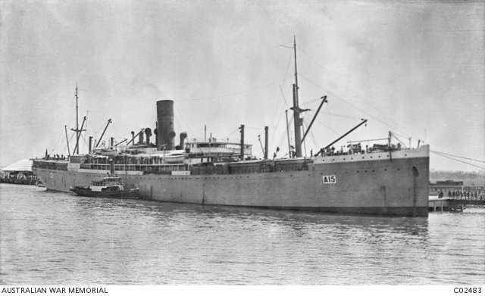
After medical corps training he embarked on HMAT Port Sydney A15 on 9th May 1917 and landed in Egypt on 20th June 1917. He was taken on strength in the 3rd Light Horse Field Ambulance and served in Egypt.
He had several stays in hospital with knee troubles.
He returned to Australia on the HMAT Aeneas on 5th February 1919. He received another medical discharge on 24th May 1919.
He received the 1914/15 Star, British War Medal and the Victory Medal.
Albert Whitlocke is commemorated on the Greensborough District Honor Roll at the RSL.

