Leonard Albert Wilkinson
Service No. 7325
Rank: Temp. Regimental Quarter Master Sergeant
Unit: 8th Battalion
Leonard Albert Wilkinson was born in Albert Park in 1891, the son of Walter Herbert Wilkinson and Louisa Elizabeth Banting. At the time of his enlistment the family was living at Southwaite Park [a property near Hobson Street], Greensborough. His next of kin was his father, Walter Wilkinson.
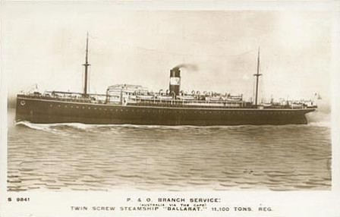
He was 24 years old 9 months and working as a Bank Manager when he enlisted on 12th April 1916.
During his training he rose rapidly through the ranks and was an acting Sergeant when he embarked on HMAT Ballarat A70 on 19th February 1917.
He was taken on strength in the 8th Battalion on 26th April 1917 and reverted to the rank of private. By 17th July he was back to acting Sergeant and he later held many temporary ranks right up to Temporary Regimental Quartermaster Sergeant.
Leonard was gassed in December 1917 and this effected his already poor eyesight. He was treated for sprained ankles several times toward the end of 1917 and early 1918.
He returned to Australia on the “Benalla” on 25th November 1919.
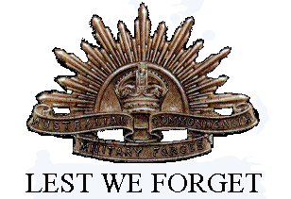
He received the British War Medal and the Victory Medal.
Leonard Wilkinson is commemorated on the Greensborough District Honor Roll at the RSL.

