Frank Hedley Winsor
Service No. 2468
Rank: Private
Unit: 4th Division Headquarters & 6th Battalion
Frank Hedley Winsor was born in Eaglehawk Victoria in 1885, the son of Alfred Winsor and Sarah Jeffrey. At the time of his enlistment his family was living at Greensborough. He was 29 years and 11 months old and working as a Lamp Cleaner for the Gas Company when he enlisted on 1st June 1915. Frank named his wife Mrs. Leonora Margaret Winsor as his Next of Kin. Frank had married Leonora Starling 1911 in Diamond Creek.
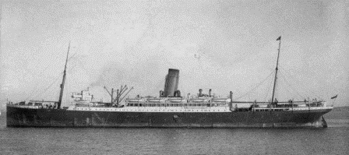
After training he embarked on HMAT Demosthenes A64 on 16th July 1915 destined for Egypt. Here he was attached to the 4th Division HQ in Alexandria and on 2nd June 1916 he left Egypt with them for England.

He was sent to France on 20th August 1917. There, he was taken on strength in the 6th Battalion on 21st November 1917.
Frank had served with the 55th Infantry band before enlisting and was promoted to Temporary Sergeant whilst acting as Band Master on the return voyage.
He returned to Australia on the City of Poona on 14th May 1919 and was discharged as medically unfit in July of that year.
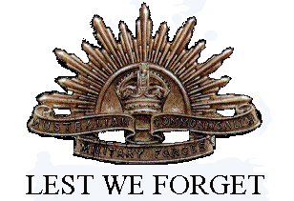
He received the 1914/1915 Star, British War Medal and the Victory Medal.
Frank and Leonora lived in Sale in 1919 and 1922, Preston (1928) and Frank was employed as a motor driver, sadly Frank died 1930 in Caulfield and Leonora in 1964.

