William Anderson Wriedt
Service No. 33261
Rank: Gunner and Temporary Sergeant
Unit: 2nd Field Ambulance Brigade, 102 Howitzer Battalion, Australian General Base Depot
William Anderson Wriedt was born in North Melbourne (Hotham) in 1887, the son of Henry Wriedt and Mollison Shaw Anderson. At the time of his enlistment the family was living at Lower Plenty. William’s father Henry Wriedt was his next of kin. William had three brothers and three sisters. He never married.
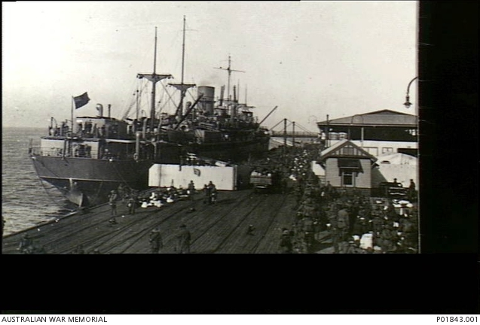
He was 29 years and 3 months old and working as an Electrotyper for Sands & McDougall when he enlisted on 16th October 1916.
After training he embarked on HMAT Shropshire A9 on 11th May 1917 and arrived at Plymouth on 19th July 1917.
He completed his training at Larkhill and was sent to France on 11th September 1917. He was taken on strength of the 1st Division Ammunition column on 24th September. On 28th November 1917 he transferred to the 2nd Field Artillery Brigade. Around this time, he was hospitalised as “sick”.
He was transferred to the permanent staff of the Australian General Base Depot on 6th March 1918. He was later promoted to Temporary Sergeant on 27th July 1918.
He returned to Australia on the Ulysses on 2nd September 1919.
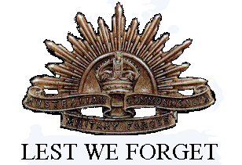
William Wriedt received the British War Medal and the Victory Medal.

