Harold Cheshire Yeaman
Service No. 5903
Rank: Private
Unit: 22nd Battalion.
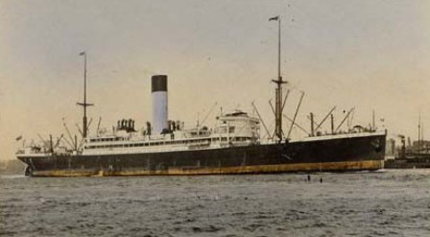
Harold Cheshire Yeaman was born in Elmore in 1884, the son of Robert Craig Yeaman and Fanny Winifred Cheshire. At the time of his enlistment the family was living at “Campaspe” Wingrove Street, Alphington. His next of kin was his father. He was 31 years and 10 months old and working as a Commercial Artist when he enlisted on 28th March 1916.
After training he embarked on HMAT Nestor A71 on 2nd October 1916 and landed at Plymouth on 16th November 1916.
He completed his training in England and was sent to France on 4th February 1917. There he was taken on strength in the 22nd Battalion.
On 3rd March 1917 he was wounded in action with a gunshot wound to his head & arm. The most serious damage was to his left elbow and he was evacuated to the Lewisham Military Hospital in England.
On 5th November 1917 he left England as medically unfit on the Thermistocles on and arrived home on 31st December 1917.
He received his medical discharge on 12th February 1918.
Harold Yeaman received the British War Medal and the Victory Medal.
Harold and his wife Louisa lived at 8 Mayfield Street, Greensborough for more than 20 years from late 1940s.
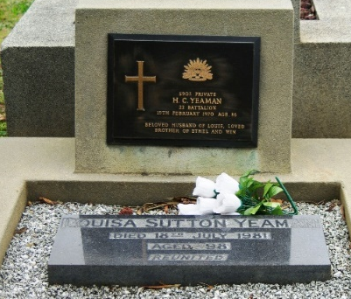
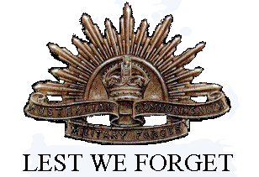
Harold passed away in February 1970 and Louisa in July 1981, they are both buried at St. Helena Cemetery.

