Jane Burgess
Rank: Staff Nurse
Unit: 1 AGH, 2 AAH, 5th Stationary Hospital
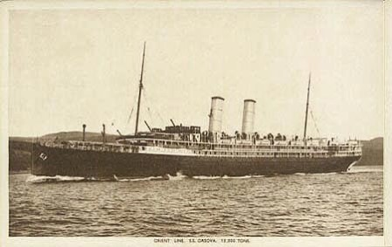
Jane was born in Flint, Wales England in 1872. At the time of her enlistment on 27th November 1916 she was 44 years old and working as a nurse. Her next of kin was given as Mrs. Isabella Jones of 69 Woodville Rd, Birkenhead.
Jane embarked on HMAT Orsova A67, on 6th December, 1916 and landed in Plymouth on 17th February 1917, then proceeded overseas to France on the 28th February and posted to 1st General Hospital in Rouen, then on 15th June to No. 47 General Hospital, then on the 5th July to No. 5 Stationary Hospital.
Jane was then transferred to England on the 4th October 1918 ex France and attached to 2nd A.G.H. Southall for duty, then detached from attached duty with 2nd A.G.H. Southall and moved to Sutton Veny.
Jane was promoted to Sister as from 6th December, 1918.
She embarked for Australia on 5th March 1919 on the “Nevasa” and arrived on 25th April, 1919.
Jane was discharged 19th June, 1919 and received the British War Medal and the Victory Medal.
Jane continued to live at the VTN Hostel until 1922 and was living at 60 Scott Street, St Kilda in 1923. She lived at the Old Colonists’ Home at Clifton Hill between the years 1931 to 1949.
It is believed that Jane died in 1958 at Brighton Victoria.
