Ivy Vera Delany
Rank: Staff Nurse
Unit: 60th, 66th, 43rd, 52nd General Hospital
Ivy Delany was born in Horsham in January 12th 1890, the daughter of Edward Delany and Mary Healey, Edward died in 1923 and Mary in 1899.
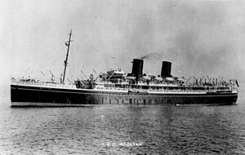
Ivy was 28 years old and working as a Nurse at Horsham District Hospital when she enlisted on 26th May, 1917. Ivy named her father Edward Delany, Firebrace Street, Horsham as her next of kin.
Ivy embarked on HMAT Mooltan, on 12th June 1917 from Melbourne when a total of 300 army nurses travelled to Suez arriving on 19th July 1917.
On 26th July Ivy departed for Salonika in Greece on the “Chagres” and on the 31st July 1917 she joined 60th General Hospital for duty, 14th August joined 66th for duty, then on 4th September was admitted to 43rd General Hospital with dysentery but marked as NYD (Not Yet Diagnosed).
On 29th August 1917 Ivy was attached to the 52nd General Hospital as a member of staff. After a spell in the Sisters Convalesce Camp she commenced nursing duties at the 52nd on 10th December 1917.
Her records indicate a Medical Board found that her condition was “dysentery fit for light duty at home, contracted in the Service and under circumstances which she had no control, in a country where dysentery is prevalent.” This was dated 20th March 1918.
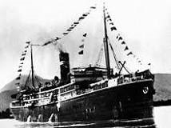
On 30th March 1918 Ivy was “invalided to Australia” on the Wiltshire.
After regaining her health in Australia, Ivy was able to serve again and on 17th September 1918 she embarked as a member of staff on the Hospital Transport Kanowna A61 from Sydney.
On 27th November Ivy was granted leave in London and 15th December she was temporarily attached to the 3rd Australian Auxiliary hospital until 3rd January 1919 when she was again attached to the Hospital Transport Kanowna for the return trip to Australia arriving on 7th March 1919 and was discharged on 7th April 1919.
She received the British War Medal and the Victory Medal.
In 1921 she was living at Dandenong Road, Armadale, occupation Nurse.

