Agnes Helena May Ferguson
Rank: Sister / Temporary Charge Sister
Unit: Colaba War Hospital Bombay
Agnes was born in Fitzroy in 1880. At the time of her enlistment on 23rd August 1915 she was 36 years old and working as a nurse at 14AAH in Macleod. Her next of kin was given as her father John Ferguson of “Glen Lisa” Waverley Street, Essendon.
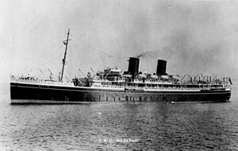
Agnes embarked on RMS Mooltan, on 26th December, 1916, landed in Bombay on 15th January 1917 and commenced service at Colaba War Hospital immediately.
Agnes was later transferred to Maymyo in Upper Burma where on 1st August 1917 she was promoted to Temporary Charge Sister.
On 28th September 1919 she was transferred back to Bombay and embarked for England on 15th October 1919 on the SS Koenig Frederich August arriving on 11th November 1919.
She ultimately came home on the Zealandic arriving on 12th May 1920.
Discharged 30th April 1921, she received the British War Medal and was Mentioned in Dispatches by General C C Monro, Military Commander in Chief of India.
Agnes died on 17th January 1961 at Heidelberg aged 80.

