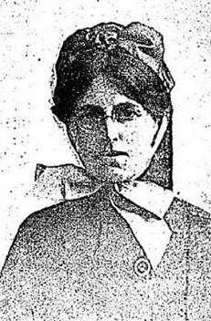
Gwladys Parker Field
Rank: Sister
Unit: 1 AGH, 2 AGH, 3 AGH, 1 AAH, 2 ACCS, 10th Stationary Hospital,
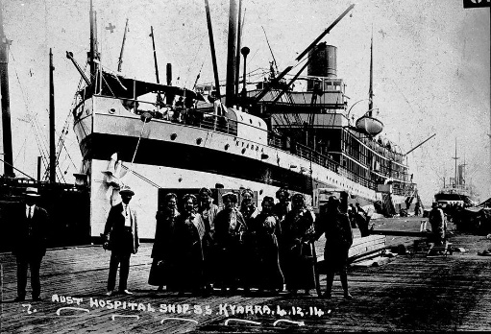
Gwladys was born in Caulfield on 22nd March 1890, the daughter of William Graham Field and Emily Sarah Laver. She was 25 years old and working as a Nurse when he enlisted on 3rd November 1914. Gwladys named her father William Graham Field, of “Hillside” Arnold Street, Bendigo as her next of kin.
She embarked on HMAT Kyarra A55, on the 5th December 1914 and landed in Egypt and served at 1AGH until 23rd September 1915, when she was transferred to England.
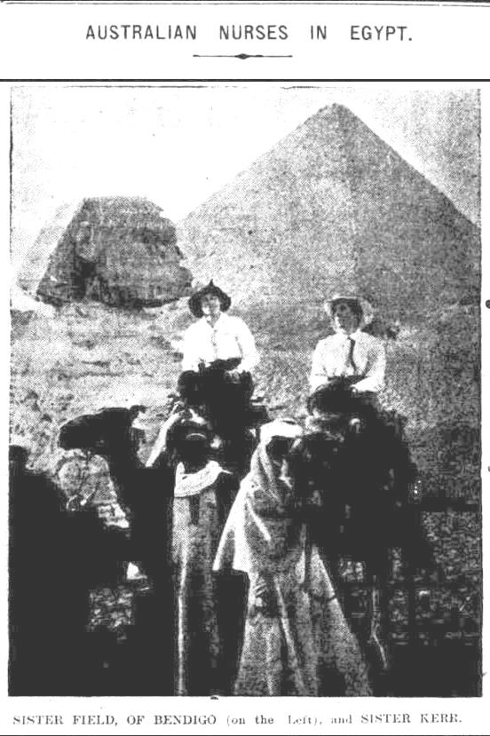
Gwladys was promoted to Sister on 1st December 1915 while serving at Queen Mary’s Military Hospital, Whalley, Lancashire. On 1st November 1916 she was transferred to 3AGH in Brighton and then to 1 AAH Harefield Park.
She was then transferred to 2 AGH in Wimereux France on 21st September 1917 until 1st January 1918 when Gwladys volunteered for service at the 2 ACCS. She was later transferred to the 10th Stationary Hospital for 1 month and then served another 3 months at 15 ACCS.
After a month of sick leave Sister Gwladys Field left for Australia from England per “Demosthenes” on the 10th January 1919 and arrived home on 2nd March 1919. During the voyage home Gwladys continued her service as a member of the ship’s Nursing Staff and was discharged on 3rd May 1919.
Gwladys received the 1914/1915 Star, British War Medal and the Victory Medal.
Gwladys was Matron of the Macleod Repatriation Sanatorium in the inter war period and in WW2 was Principal Matron of the AAMC (Southern Command).
She never married and died in St. Kilda in 1970.

