Caroline Elizabeth (Bessie) Gallagher
Rank: Staff Nurse / Sister
Bessie was born in 1884 at Wentworth NSW, just across the Murray River from Mildura.
Her parents George Gallagher and Elizabeth Mary Jackson had married in 1883.
Bessie trained for 3 years at Maryborough Hospital as a Nursing Sister and variously worked at Deniliquin Public Hospital, Melbourne Women’s Hospital, NSW Bush Nursing Association (Cottage Hospital Scheme), Euston Hospital 1911, Mildura Hospital 1914 and finally Mont Park in 1915. Bessie is mentioned in the following extracts from Trove.
Riverina Recorder (Balranald, NSW), Wed 8 Nov 1911 (p.3):
THE DISTRICT
Euston
Nurse Gallagher of Mildura, has been appointed to the vacant position in the New South Wales Bush Nursing Association at Euston. Nurse Gallagher has had an extensive experience, having trained in the Maryborough Hospital, the Deniliquin Public Hospital, and the Women’s Hospital, Melbourne. She is a member of the Royal Victorian Trained Nurses’ Association.
Riverina Recorder (Balranald, NSW), Wed 16 Apr 1913 (p.2):
DISTRICT NEWS
Euston
By last Sunday’s coach Nurse Brown, who for several months has been acting as temporary bush nurse, left for Sydney, and unfortunately for the district, the Association will be without a nurse at Euston. Every inducement was offered Miss Brown to make her stay permanent owing to Nurse Gallagher being ordered six months rest, but without success. …………………………………
In all she had 11 years experience in “Nursing Orders” before enlisting in the Australian Army Nursing Service on 6th October 1915.
The Mildura Cultivator (Vic), Sat 9 Oct 1915 (p.10):
LOCAL NEWS
Nurse Bessie Gallagher will be back in Mildura this morning for ten days’ final leave, before proceeding to the front about the end of the month.
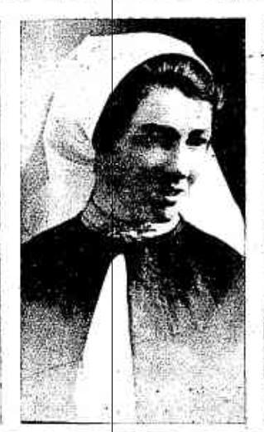
The Mildura Cultivator (Vic), Sat 23 Oct 1915 (p.12):
Social Letter
Miss Bessie Gallagher was “At Home” to her friends on Thursday afternoon of last week and a great many availed themselves of the opportunity of bidding her bon voyage and good luck. She returned to the Mont Park Hospital last Monday, where she will remain until she sails. She showed her interested visitors the military nursing uniform, which is a dark grey zephyr one-piece frock, fastened with metal Commonwealth buttons and the rising sun brooch. On the left arm is a medallion with a red cross in the centre and round it inscribed “Army Nursing Corps.” With this is worn a grey or white apron and on the shoulders a short red cape, with a white collar just showing above the straight grey one. For out-door wear a grey tailor-made skirt and shirt blouse is worn and over it a grey coat similar to those worn by the soldiers.
(left) Sister Bessie Gallagher from Punch 2nd December 1915

Home for Bessie at this time was Lime Avenue, Mildura, where her now widowed mother lived with two of her sisters, Lillie and Alice. Another sister Myrtle was also a trained nurse and also served in WW1, as did her brother Godfrey DOW 1916.
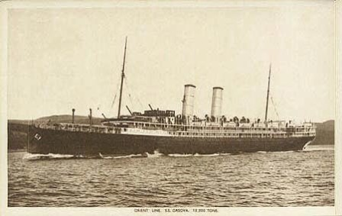
Bessie embarked from Australia on the HMAT Orsova A67 on 12th November 1915, her rank was Staff Nurse.
Bessie served in a number of various locations during her time in “The Colours”. These included Mudros, Egypt, England, India, Malta, Belgium and France. As well as these she served “At Sea” on a number of Hospital Ships and on Medical Transfers bringing patients out of the war zones and back to England or India.
In 1916 Bessie narrowly missed being torpedoed as the following letter shows:
Mildura Telegraph and Darling and Lower Murray Advocate (Vic), Fri 26 Jan 1917 (p.3): LOSS OF THE BRITANNIC
LETTER FROM NURSE BESSIE GALLAGHER
Mrs Gallagher, of Lime Avenue, is in receipt of the following interesting letter from her daughter, Nurse Bessie Gallagher, now of the Hospital Ship Grantully Castle. The letter is as follows: -
“I wrote to you when we were at Salonica, but I do not expect you will ever get it from there. I expect you have heard of the enemies latest vile doings. They torpedoed the largest ship afloat, now used as a hospital ship called the Britannic on the 21st of November. We were two days out at sea when we heard of the news. The ship held 4000 people other than staff – medical and crew. The Britannic was on her way from England to Mudros, and the accident happened in the Zea Channel. Several ships left Malta with patients for the Britannic to meet her at Mudros. We were in Malta getting the boilers mended, so did not go. We were late in getting away so the “Braemar Castle” did our run from Salonika to Malta, and on November 22 she was torpedoed with 400 patients on board, while going to Malta. Everybody was saved when we passed. She was beached off an island in the Aegean Sea. This would have been our fate if the boilers had not needed attention. When we arrived at Salonika we were ordered at once to go to Athens for the survivors of the Britannic. It took us three days to arrive there. The day we arrived, on November 27th, we had a look round; it is the very old historical place you read of, and full of ruins. That evening we took on patients – 45 men badly wounded. They were orderlies and ships crews. There are 33 missing. All sisters and V.A.D. are saved. The accident happened at 8.15 a.m., and all were at breakfast. They had a shot at her from both sides, two torpedoes, but one missed. What a merciful blessing she took 55 minutes to sink. The poor girls just got away with what they stood up in. The girls and survivors were picked up by our torpedo destroyers. They were only about two hours before they received help. Then they went to Athens till we called for them. I believe the girls were wonderful – over 90 of them and no confusion. They might have been going to a picnic the way they handed them from one boat to another. One medical man is missing, and one dangerously injured. We are taking the survivors to Malta, then they are going to England. I do hope we do not take them home because I want to stay out now till my time is up. I am so pleased I am here. Sister Steele and myself are the only two Australians and it will be handed down in history the sinking of the Britannic, a hospital ship, and we two are representing Australia; to think we two were the ones who went to the help of the survivors.
My time will be nearly up when you receive this letter. When I see the wounded and the state they are in I think our poor brother is much better off. I wonder what the Huns will do next? They say the accident could not have happened at a better time. No patients, and all gathered together at breakfast; only 38 missing out of 1000 and some hundreds of a crew. That is including the ones killed by explosion. I have my suit case packed with a few clothes, and I have my R.V.T.N.A. badge as an identification disc, so I am quite prepared if the hellish Hun have a go at us. I wrote to the matron of the 44th Casualty Clearing Station, France, where poor Godfrey died for all particulars, and if he had anything on him when he came in, and they will send it on to you. I am looking and feeling so well, although the shock and casualties of the Britannic shook us up a bit. We were allowed to have a look over her the last time she was at Mudros, when we were there with patients for her. We expect to be in Malta tomorrow. If I get time in Malta I will send you a cable, because I know how anxious you will be. Lots of love to all; hoping to be home for next Christmas; perhaps we will be in England for this.”
However, she was not exempt from personal illness and in December 1917 was hospitalised for six months with duodenal ulcers. When she recovered she went straight back to France.
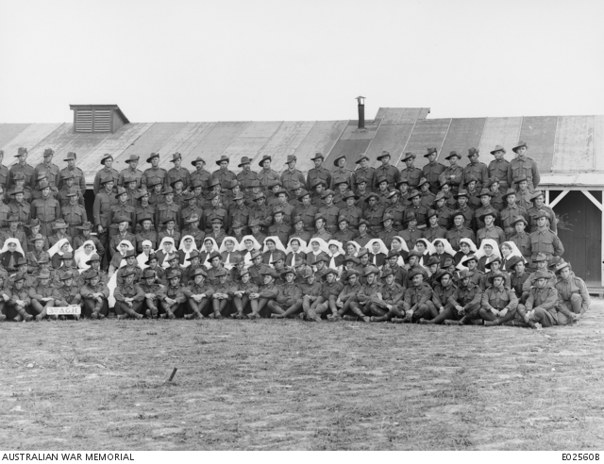

The picture right was taken on 23rd June 1918 at the 3AGH. Bessie is second from the right.
Staff of 3AGH 23/06/1918

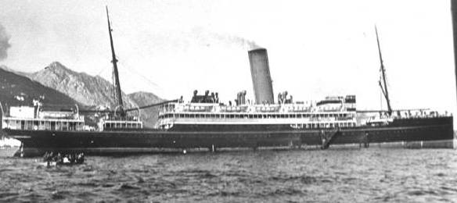
On 1st October 1918 Bessie was promoted to Sister and finally returned to Australia on the SS Zealandic on 23rd August 1919.

For her services she received the 1914/15 Star, the British War Medal and the Victory Medal.
On 9th September 1919 Bessie was “brought to the notice of the Secretary for War for valuable services rendered in connection with the war.”
Bessie became engaged to William Henry Cox a Mildura man and horticulturalist. William had served in WW1 in the 3rd Field Artillery Brigade as a Bombardier.
On 27th April 1921 Bessie married William Henry Cox at the Presbyterian Church in Alma Road, St Kilda. They lived in Cowra Avenue, Mildura and had two children Jean b 1922 and Neil b 1924.
William died on 10th September 1947 and was cremated at Springvale.
Bessie died on 12th March 1958 at Mooroopna and was also cremated at Springvale.
They are both together in Tristania Garden F3, Bed 7, Rose 4.

Norm Colvin
11/01/15

