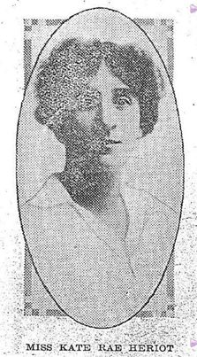
Katie Rae Heriot
Rank: Staff Nurse
Unit: Queen Alexandra Imperial Military Nursing Service Reserve (QAIMNSR),

Katie was born in Williamstown in 1883, the daughter of Andrew Simpson Heriot and Catherine Isabella Rae. She was 32 years old and working as a Nurse when she enlisted in 1915.

She embarked on SS Orontes on 14th April 1915 and landed at Tilbury England and served with the QAIMNSR. Queen Alexandra's Imperial Military Nursing Service
Katie served in England and France for the remainder of the war and returned to Australia in October 1918 on the HT Runic. She continued to serve at the 5AGH in St Kilda Rd, Melbourne and 16 AGH in Macleod.
Katie was mentioned in dispatches by Field-Marshal Viscount French and received the 1914/1915 Star, British War Medal and the Victory Medal.
Katie married Walter Le Brun in 1920 and died in 1977 aged 94.

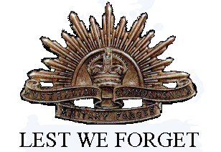

Weekly Times (Melbourne, Vic.) Saturday 8 January 1916:
“NURSES WIN HONOR
FIRING LINE FACED
For some time Mr A. S. Heriot, formerly mayor of Williamstown, had known that his daughter Miss K. R. Heriot had been selected for special army service, so the news that she had been recommended by Field-Marshal Viscount French for distinguished service did not come as a surprise to her relatives.
In October she was right in the thick of the fray, working with a special army corps in close proximity to the firing line in France. She was among the first British nurses to undertake this dangerous duty.
Her last letter indicated that she had marching orders to leave France and join a special nursing unit at Lahore Hospital, Calais. Probably she is still at that centre.
Miss Heriot was a trainee of the Homoeopathic Hospital, Melbourne. She also had some experience at the Women's Hospital. For a time she was acting matron at the Homoeopathic Hospital, Sydney, and later left for West Australia, where she was associated with the Fremantle Hospital.
She volunteered for service twelve months ago, and eventually went to France as a member of the Queen Alexandra Imperial Nursing Reserve. When bound for England she had a most exciting time on the Orontes. It was that eventful trip when the Orontes had to steer clear of a submarine which had manifested a warm interest in British ocean liners. For days and nights the passengers did not discard their life belts.
Some years ago Miss Heriot took a great interest in aquatic sports, and was in the front rank of successful competitors at the swimming matches organised by various women's clubs. Her young brother, Lieutenant F. W. Heriot, R.A.N.R., is attached to the Australian Navy. …
It is worthy of note that the majority of the nurses figuring on the honor list are members of the Royal Victorian Trained Nurses' Association. This is a feather in the cap of the educational side of. the movement.
By the association all Victorian nurses are trained to a uniform standard of proficiency. For instance, if a trainee enters a small country hospital later, she is advised to reach the set standard by taking supplementary training.
British nurses have not the privilege of educational unity through standardisation. Probably this is why the Australian nurses score in England. It is said that medical men there are always eager to secure their services.
In America each State has its own standard, and the period of training varies in each State.”

