Olive Isabel Laycock
Rank: Staff Nurse
Olive was born in Beechworth on 5th January 1893, the daughter of Harry Rowley Laycock and Annie Jones. She was 25 years old and working as a Nurse when she enlisted on 16th January 1918. Olive named her mother Mrs. Annie Laycock as her next of kin.
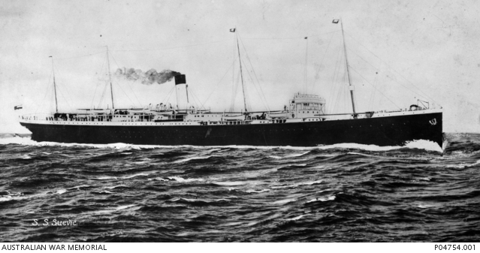
She embarked on HMAT Themistocles A32, and landed in Sydney 28th January 1918; embarked and landed in Liverpool 29th March 1918, attached to No.2 A.A.H. for duty, then detached for return to Australia on the Hospital Ship “Suevic” A29 as a member of the medical staff on the 21st April, 1918.
Hospital Ship Suevic
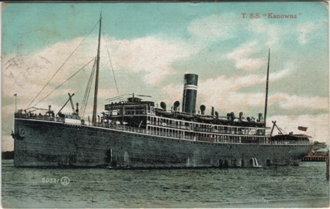
Olive again embarked at Sydney on HMAHS Kanowna A61 on 17th September 1918 and returned to Australia on the HMAHS Kanowna on 7th March 1919 was discharged on 30th March 1919.
HMAHS Kanowna
Olive received the British War Medal and the Victory Medal.

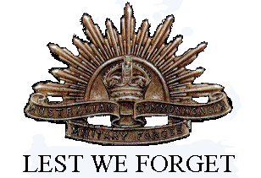
Her brothers both enlisted, William Thomas Laycock Service No. 10635, Sapper (British War Medal and Victory Medal); and, Sergeant Stanley Laycock Service No. 2729, Killed in Action 23rd September 1917 (Military Medal, 1914/15 Star, British War Medal, Victory Medal and Anzac Commemorative Medallion).
Olive married Oswald Dahlenburg on 27th March 1926 at St James Cathedral, West Melbourne.
Olive died in 1972 at Horsham and Oswald 1973 at Nhill.

