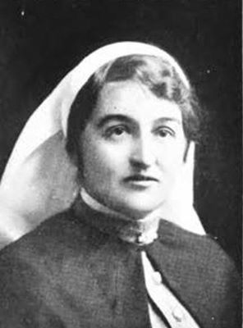
Catherine McGileray Munro
Catherine was born in Mortlake in 1876 the daughter of Donald McGileray Munro and Catherine McKenzie. She claimed to be 35 years old and working as a Nurse when she enlisted on 24th June 1915.
Catherine named her father Donald McGileray Munro, of Warragul as her next of kin.
Embarked on HMAT Orsova A67, on 17th July 1915 destined for the Hospital ship Kanowna.
Sister C. Munro of the Nursing Staff of H.M.A.H. ship No. 2 “Kanowna” was appointed Head Sister on 1st March 1916. Did 3 trips per Kanowna. She also served on Hospital Ships, Wiltshire, Euripedes and Osterley.
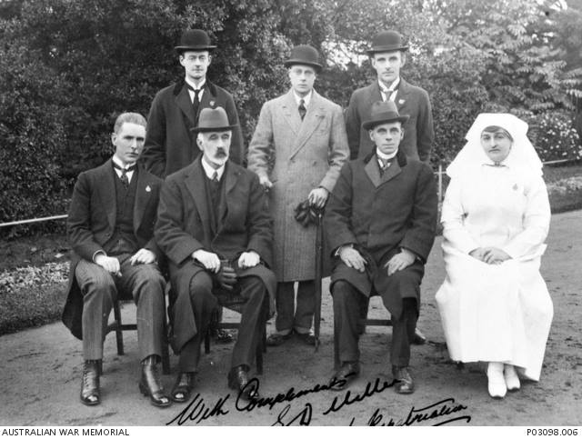
Matron Munro at the ANZAC Hostel in Brighton
She returned to Australia on the “Miltiades” as a staff member on 7th July 1917 and was discharged 17th July 1918.
Catherine received the 1914/1915 Star, British War Medal and the Victory Medal.

In 1919 Catherine was appointed Matron of the newly created ANZAC Hostel in Brighton which could hold up to 25 patients and seven nurses under Matron C. Munro.
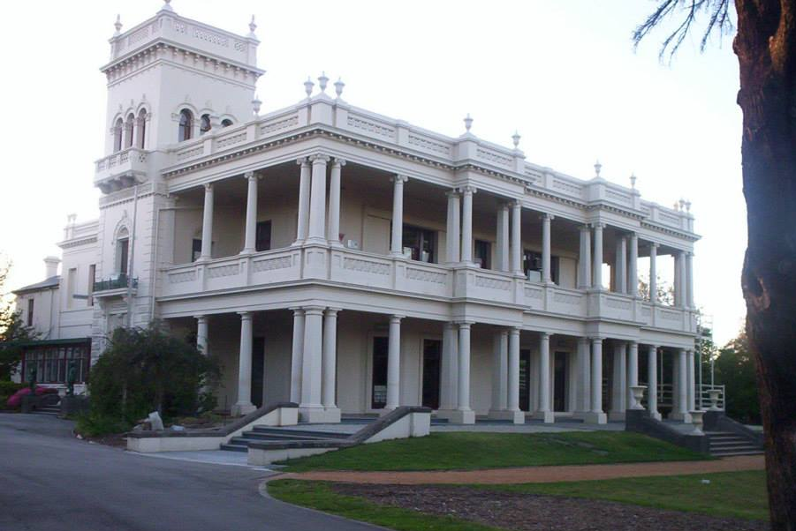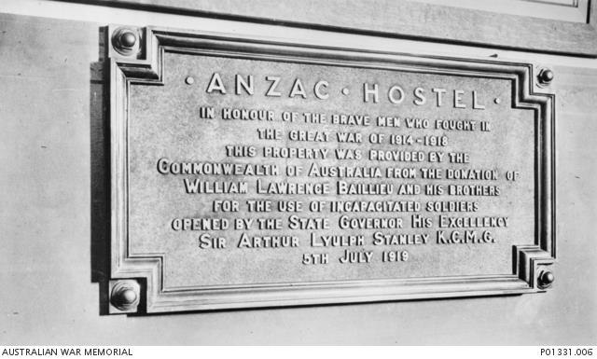

Catherine married Norman Leslie Gorrie in 1929.
Sadly she passed away in 1968 age 92 in St Kilda.
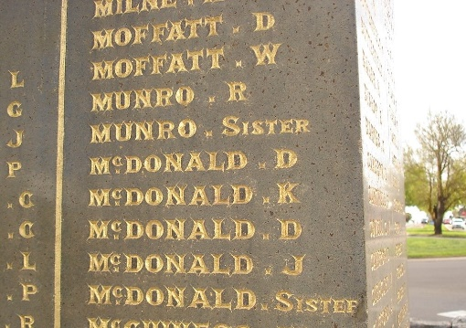

Sister Munro is commemorated on the Mortlake War Memorial.

