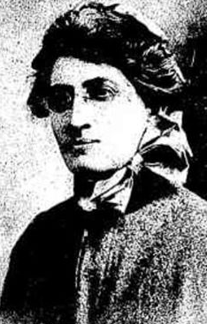
Mary Elizabeth Jane Roberts
Mary was born in Molesworth in 1873 the daughter of Thomas Frederick Roberts and Elizabeth Couch. She was 42 years old and working as a Nurse when she enlisted on 11th August 1915.
Mary named her mother Elizabeth, of 114 Westgarth St, Fairfield as her next of kin.

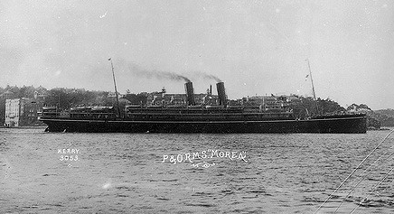
Mary embarked on RMS Morea, on 24th August 1915 with soldiers from 9th Light Horse Regiment, 3rd Light Horse Brigade 8th reinforcements.
Mary served in Egypt until December 1915 and then returned to Australia on the HMAT Thermistocles A32 on 2nd January 1916.
After her returned to Australia, Mary continued her service in Military Hospitals namely, No. 5 (St Kilda Road Melbourne) and No. 11 (Caulfield) until at least 1918.
Mary received the 1914/1915 Star, British War Medal and the Victory Medal.
Mary passed away in 1955 aged 82 in Elsternwick.

