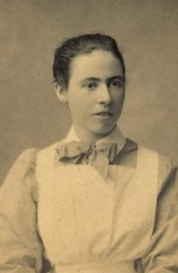
Alice Victoria Rogers

Alice was born in Balranald in 1889 the daughter of James Rogers and Marie Emma Maynard. She was 27 years old and working as a Nurse when she enlisted on 11th December 1916.
Alice named her mother Marie Walton, of “Wahroonga” Paxton Street, East Malvern as her next of kin.
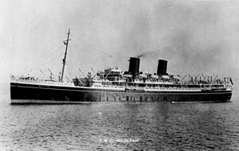

Alice embarked on RMS Mooltan, on 26th December 1916 and served with the Indian Nursing Service until she contracted malaria.

In May 1918 Alice embarked for Australia and arrived on 3rd June 1918, she was discharged on 25th November 1918.
Alice received the British War Medal and the Victory Medal.
In 1922 Alice married James Thomas Owen.
Alice passed away in 1971 aged 80 in Bentleigh.
